**TABLE OF CONTENTS**

* **Objective……………………………………….01**
* **Technology Stack…...…………………….……01**
* **Dataset Description…………………….….01-03**
* **Model used and visualization………...………04-17**

1. UNETR………………………………………………5-9
2. UNET ……………………………………………….10-14
3. DETR ………………………………………………..15-18

* **Formulae…………………………………..18**
* **Front-end design……………………...……19-26**
* **Flask Framework…………….……………27-33**
* **Deployment…………...……………………33-34**
* **GPU vs TPU Training……………………...35-37**
* **Platforms Used……………………………………...38 - 39**

1. AWS Sage maker

* **Project Screenshots…………………………… 40 - 48**
* **Summary………………………….…………... 48**
* **References ………………………….………….49**

**Objective:**

1. Create a mobile application for multiorgan segmentation
2. Implement a transformer-based architecture for segmenting organs in Abdomen CT Images
3. Integrate the mobile application and the algorithm
4. Deploy it on Cloud

**Technology Stack:**

1. **Flutter:**

Flutter is an open-source UI software development toolkit created by Google for building applications for mobile, web and desktop

1. User Authentication using **Google Firebase**
2. **Deep Learning Framework:**

**TensorFlow:** It’s a DL framework that provide tools and libraries for building and training neural network models.

1. **Data Preprocessing**:

**NumPy, OpenCV:** General-purpose data processing libraries often used for preparing datasets before training a machine learning model

1. **Model Training Infrastructure**:

**GPUs and TPUs:** Graphics Processing Units (GPUs) or Tensor Processing Units (TPUs) may be used for accelerated model training, especially for large-scale Transformer models.

1. Deployment using **Amazon Web Services (AWS**)

**Dataset Description:**

**Name:** Synapse multi-organ segmentation dataset

**Source:** Synapse website

|  |  |  |  |
| --- | --- | --- | --- |
|  | **Images** | **Respective masks** | **Total** |
| **Before Augmentation** | 4720 | 4720 | 9440 |

**Link:** [Multi-Atlas Labelling Beyond the Cranial Vault - Workshop and Challenge - syn3193805 - Wiki (synapse.org)](https://www.synapse.org/" \l "!Synapse:syn3193805/wiki/217789)

We use the 30 abdominal CT scans in the MICCAI 2015 Multi-Atlas Abdomen Labelling Challenge, with 3779 axial contrast-enhanced abdominal clinical CT images in total. Each CT volume consists of 85 voxel spatial resolution of ([054 198 slices of 512 512 pixels, with a 054] [098 098] [25 50]) mm3.

Out of 30 folders, we have used 2 folders of data for our project, in total there are 4720 masks and 4720 images along with a .mat file considering 11 classes (10 organs+1 background)

**Image Preprocessing:**

We extracted two folders (folder 0001 and folder 0002) from the complete dataset and converted then into colour images manually: -

Greyscale values were in 5 categories;

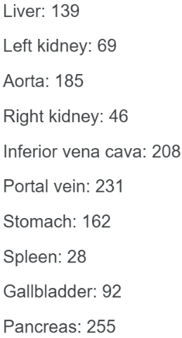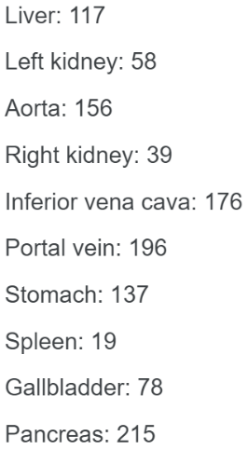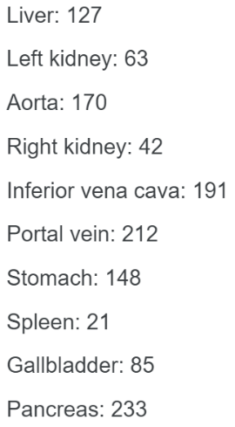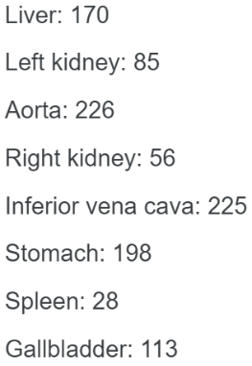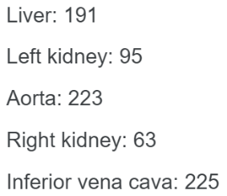

All the grey values were converted manually into colour images of same pixel values for each organ in a folder using the following code;

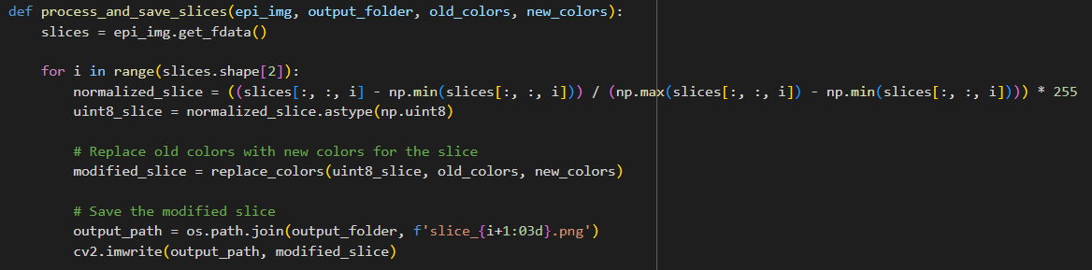

**Colour labels of masks:**

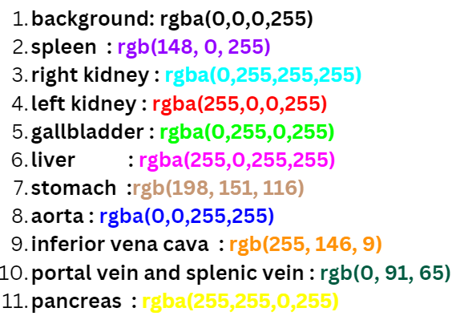

**Images:**

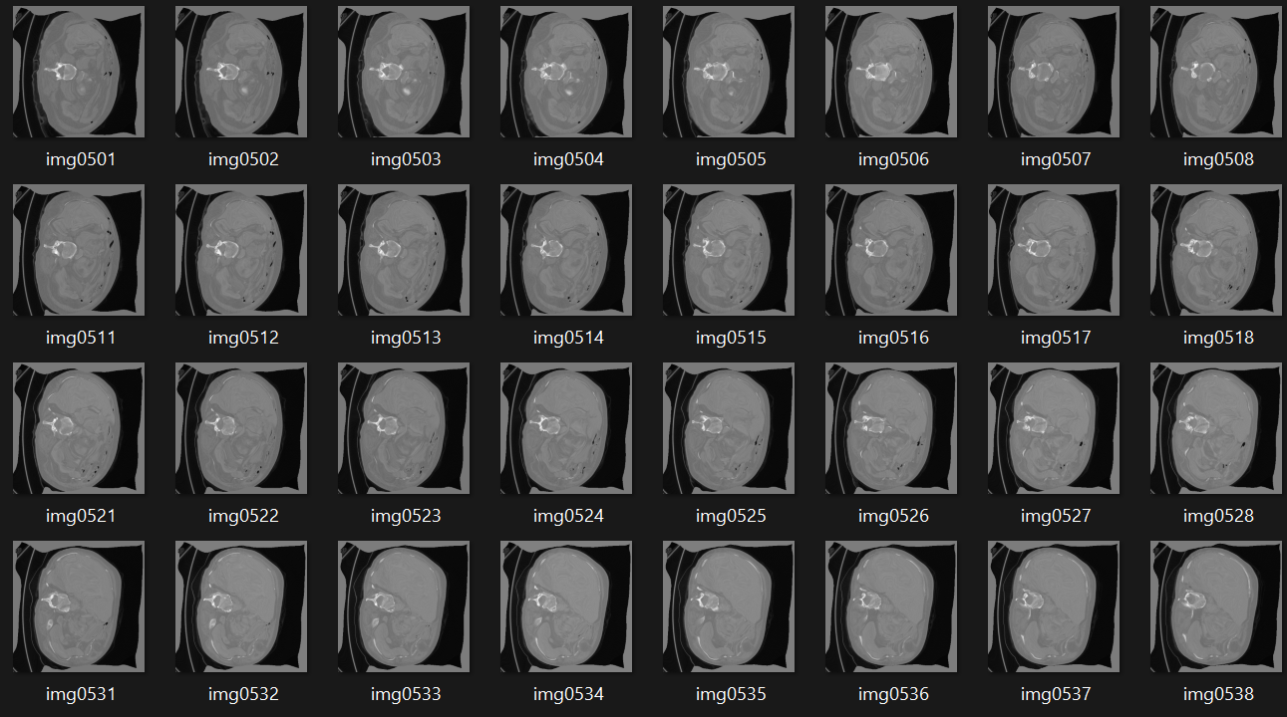

**Respective masks:**

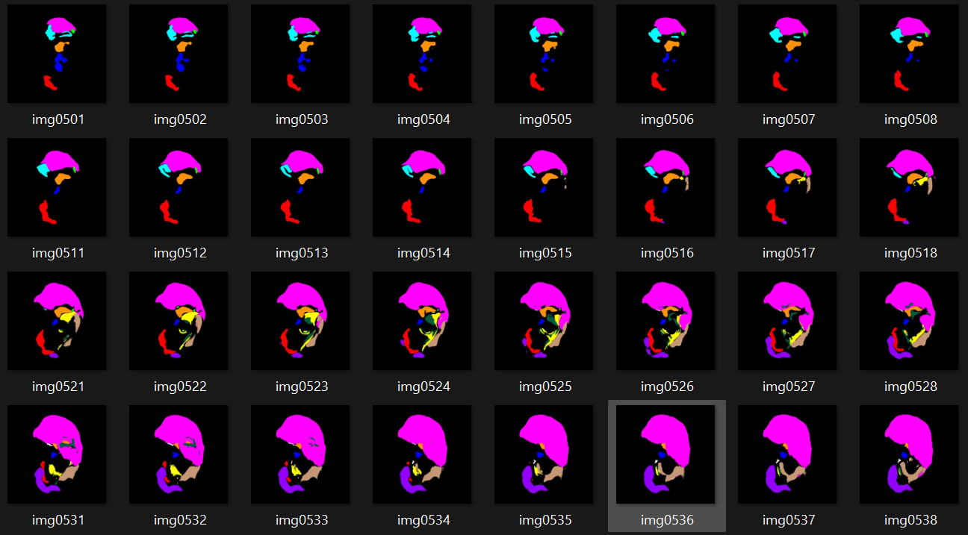

**Models Used:**

* We trained two models on our Synapse dataset such as UNETR, UNET and DETR on bone fracture dataset.
* The below flowchart represents different models and the respective Dice score.

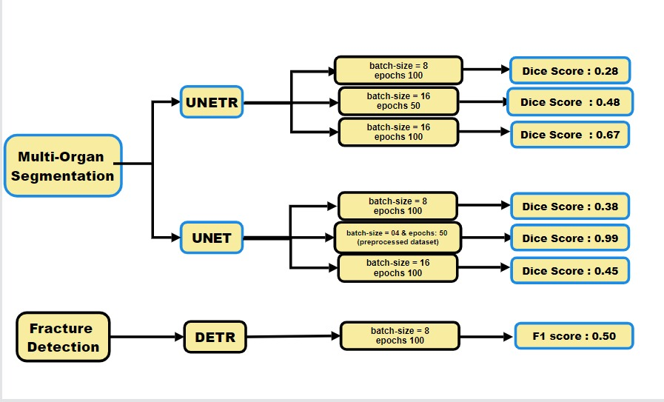

**UNETR MODEL:**

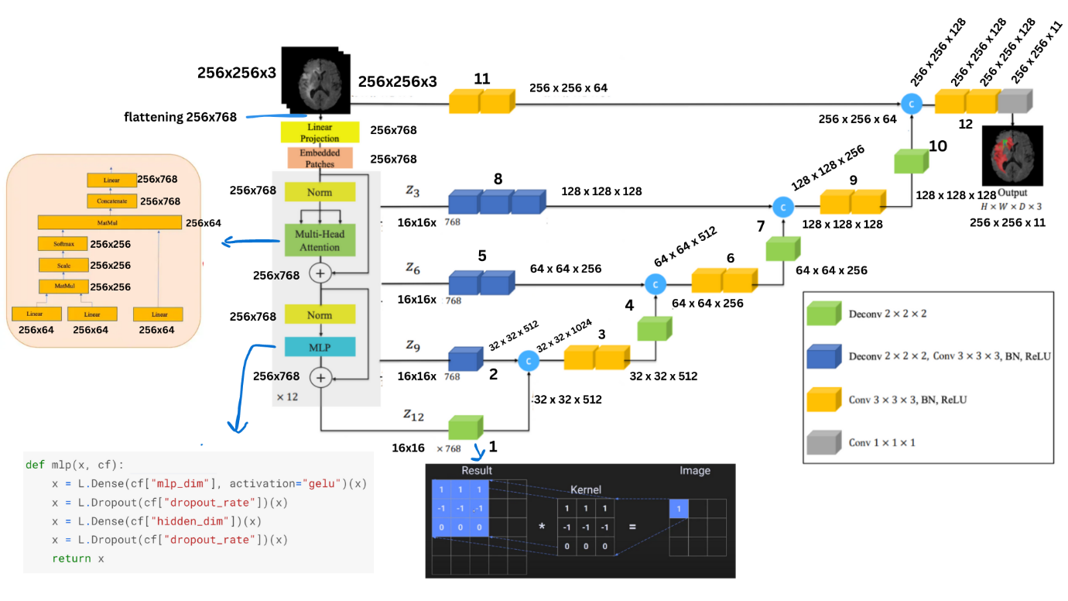

UNETR, it Consist of Vision Transformer as encoder and CNN based Decoder, The Vision Transformer is used due to its global context understanding (consider the entire image for context), parameter efficiency, flexibility with input sizes, and attention mechanisms. Connected to a CNN-based decoder via skip connections, The encoder processes the raw pixel information and converts it into a set of feature maps that capture meaningful patterns and hierarchical features and the decoder up sample the extracted features where the final output is fed into a 1×1 convolutional layer with a SoftMax activation function to generate semantic predictions.

**Detail information:**

**Encoder block:**

* Before going into the encoder block, a 256x256x3 image is reshaped into a flat array of 256x768 pixel values. In the linear projection block, these pixel values are transformed into higher-dimensional values using dense layers. The weights in these dense layers are initialized using the Glorot initializer, which assigns random values within a specific range.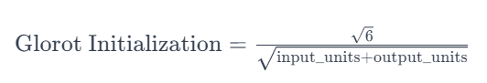 Following the linear projection, an embedded block assigns embeddings to 256 positions of size 768. These embeddings are then added to the earlier obtained higher-dimensional values (256x768).

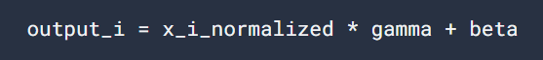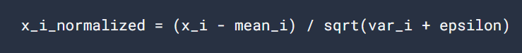

* The input of size 256x768 goes through encoder normalization. Then, in the multi-head attention block, which utilizes 12 heads, the input is divided, and for each head, the matrices for q, k, and v are of size 256x64. The scaled softmax output of the q * k^T matrix is multiplied with the value matrix. The results from all 12 heads are concatenated to form a 256x768 matrix, which then enters a linear layer. 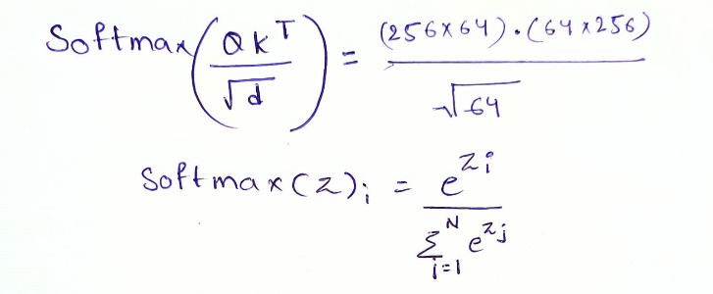
* The output of the multi-head attention block is added to the initial input (256x768), and this combined result undergoes normalization. It then goes through a multilayer perceptron block, consisting of a dense layer with ReLU activation, a dropout layer, another dense layer, and another dropout layer. The output of the first dense layer is a matrix of size 256x3072, and the output of the second dense layer is a matrix of size 256x768.

**Decoder block:**

* The input to Decoder block is the output of 12 Layered Encoder block which is of size 256 x 786 which will be reshaped according to 16 x 16 x 786 because of input formats for Conv and DeConv blocks.
* DeConv block every time doubles the size of input whereas Conv block performs simple Convolution followed by Batch Normalization and ReLu Activation Function without any change in input shape.
* The Purpose of Batch Normalization is to achiever faster convergence and ReLu activation function is to introduce non-linearity into the architecture.
* The below information shows you the step wise conversation of image and its shapes:
* 16 x 16 x 768 🡪 32 x 32 x 512 🡪 64 x 64 x 256 🡪 128 x 128 x 128 🡪 256 x 256 x128 🡪 256 x 256 x 11
* At last a 1 x 1 convolution block with **11** (Number of classes) filter with a ***SOFTMAX*** activation function is applied to get the Probability Distribution Scores of Each class along each pixel.
* This way, the decoder plays a crucial role in generating high-resolution semantic segmentation maps from low-resolution transformer encoder features. Using skip connections, it recovers spatial details lost during down sampling. The decoder relies on fully convolutional neural network layers. This design enables effective fusion of global contextual information with localized features for accurate multi-organ segmentation.
* Top of Form

**Model summary:**

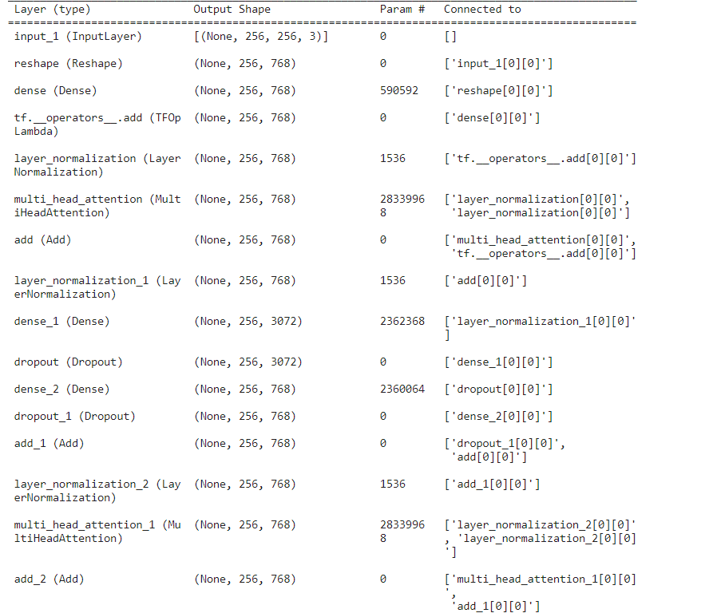

…………………………………………………………………………

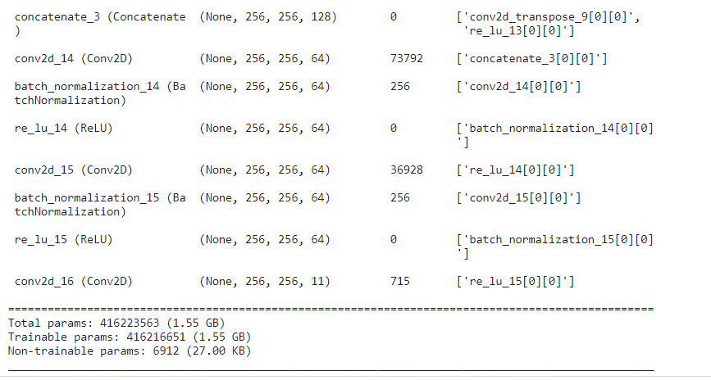

**Model prediction:**

Number of epochs : 100

Metrices:

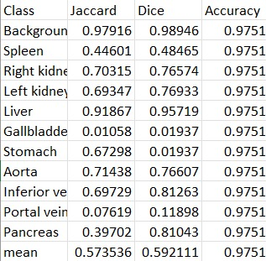

**Input image ground truth prediction Overlapping**

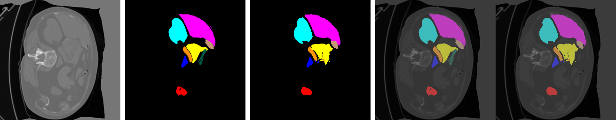

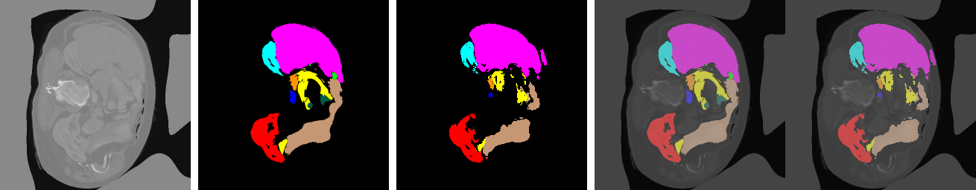

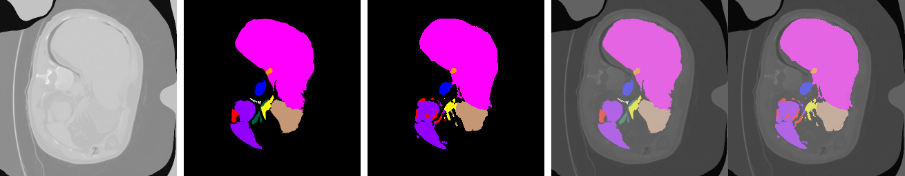

**UNET MODEL:**

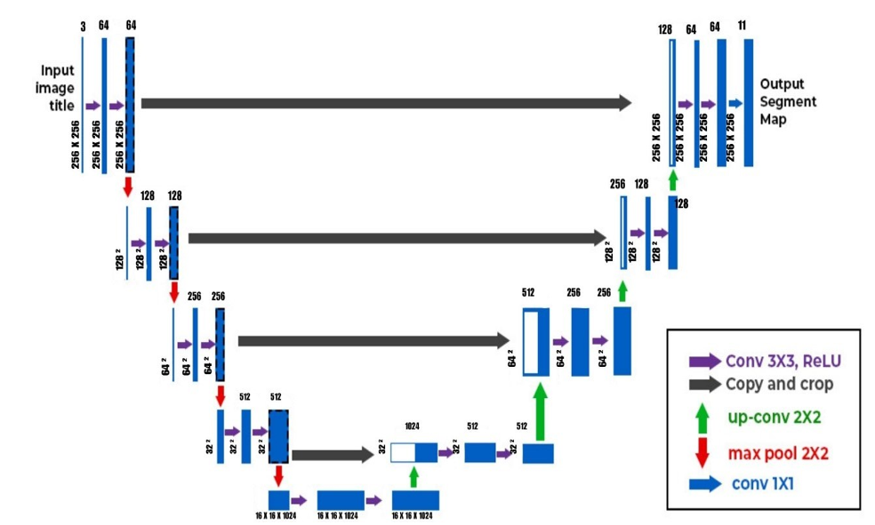

U-Net is an architecture for semantic segmentation. It consists of a contracting path and an expansive path. The contracting path follows the typical architecture of a convolutional network. It consists of the repeated application of two 3x3 convolutions (unpadded convolutions), each followed by a rectified linear unit ([ReLU](https://paperswithcode.com/method/relu)) and a 2x2 [max pooling](https://paperswithcode.com/method/max-pooling) operation with stride 2 for down sampling. At each down sampling step, we double the number of feature channels. Every step in the expansive path consists of an up sampling of the feature map followed by a 2x2 [convolution](https://paperswithcode.com/method/convolution) (“convTranspose2d”) that halves the number of feature channels, a concatenation with the correspondingly feature map from the contracting path, and two 3x3 convolutions, each followed by a ReLU. At the final layer a [1x1 convolution](https://paperswithcode.com/method/1x1-convolution) is used to map each 64-component feature vector to the desired number of classes (here 11 classes).

**Convolutions:**

Convolutions in image processing involve applying filter weights to image pixels through matrix multiplications ("element-wise multiplication"). These filters help identify various features in images, and as the number of filters increases, the system can capture a greater variety of features. The result of each matrix multiplication is a feature map, highlighting specific aspects or patterns within the image.

Note: In convolutional operations, the number of channels in the filter matches the input channels. Matrix multiplications are done independently for each channel, with the filter applied to corresponding regions of the image. The results are summed across channels to produce a single value at each position, creating feature maps that capture different aspects of the input.

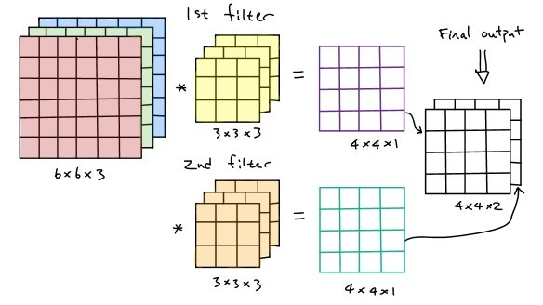

**The Segmentation mask :**

outputs = Conv2D(num_classes, 1, padding="same",activation= “softmax”)(d4)

This code is for segmenting images into 11 different classes (like organs). It takes an input image and, through a network (UNET), outputs a segmented image where each pixel is assigned a probability of belonging to one of the nine classes.

The "categorical_crossentropy" is a measure used during training to make sure the predicted segmentation aligns well with the actual segmentation in the training data. It measures the dissimilarity between the predicted probability distribution and the true probability distribution of the classes, this helps the system learn to accurately segment images into the specified 11 classes.

Note: d4 refer to the output of last decoder block, whose dimensions are 512 * 512 * 64, Look at the above architecture for better understanding.

**Model summary:**

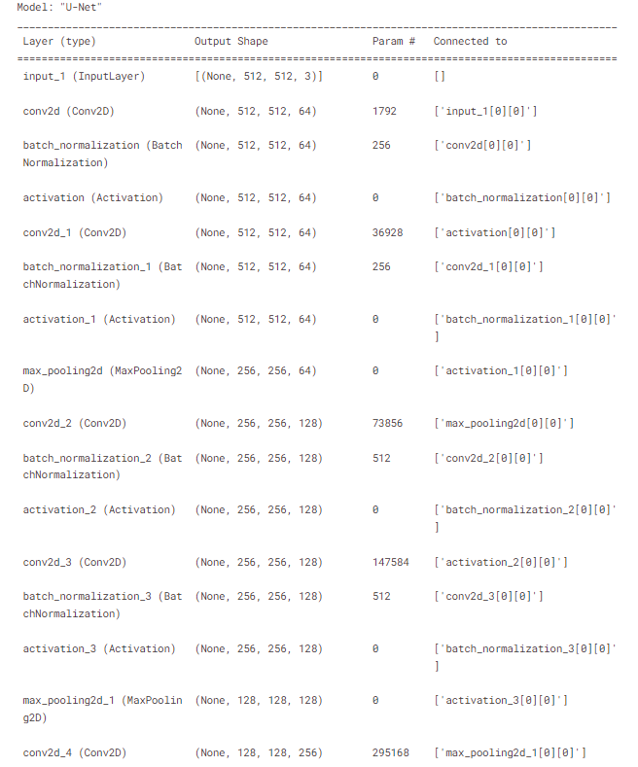…………………………………………………………………………………………………………… 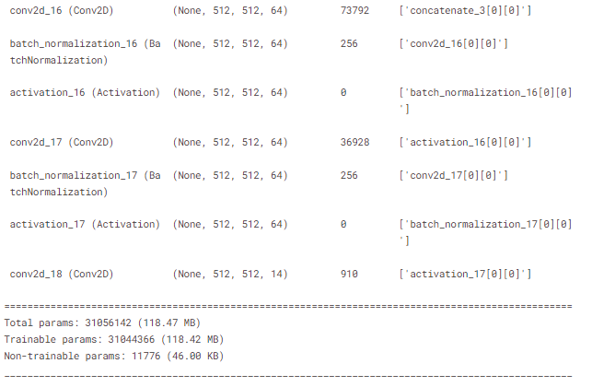

**Model prediction:**

Number of epochs : 100

Metrices:

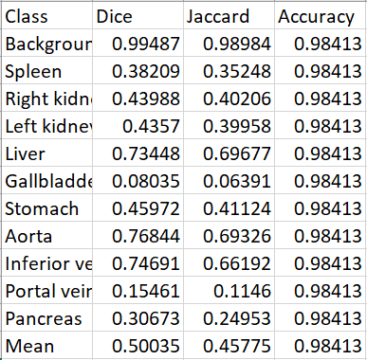

**Input image ground truth prediction Overlapping**

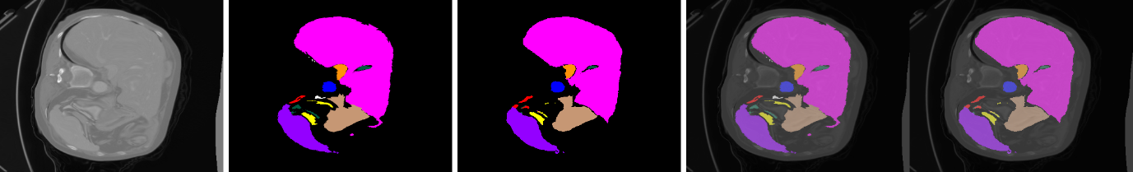

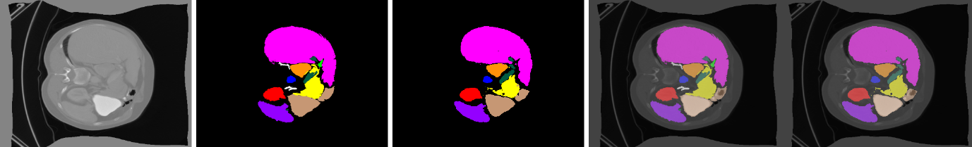

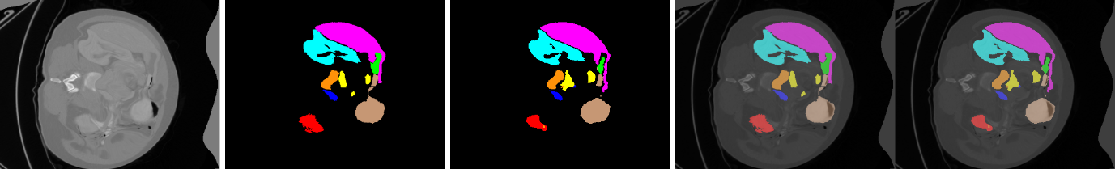

**DETR MODEL:**

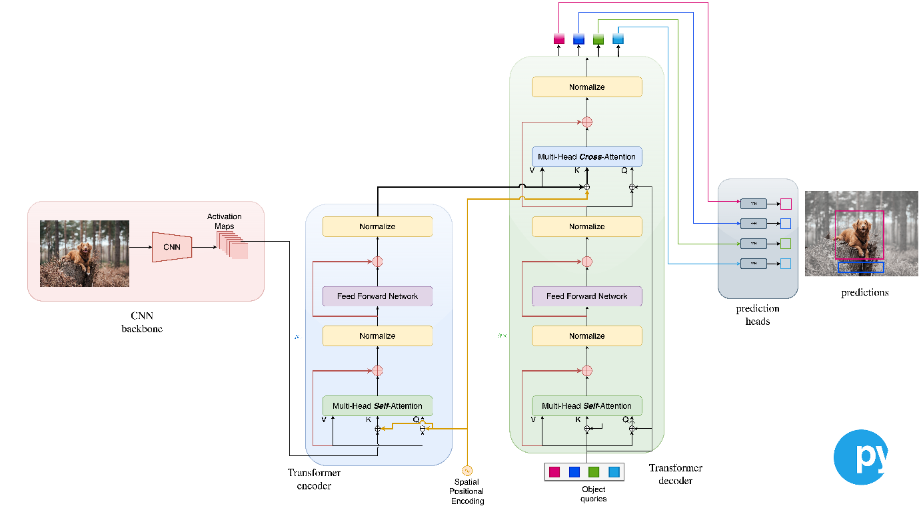

* DETR (Detection Transformer) is a deep learning model for object detection. DETR leverages the Transformer architecture, originally designed for natural language processing (NLP) tasks, as its main component to address the object detection problem in a unique and highly effective manner.
* The primary component of DETR's architecture is the Transformer. The Transformer is a neural network architecture known for its self-attention mechanism, which enables it to capture complex relationships and dependencies between elements in a sequence or set of data. In the context of DETR, the Transformer's self-attention mechanism plays a pivotal role in understanding the content and spatial relationships of objects in an image
* Number of epochs = 100, Batch size =8

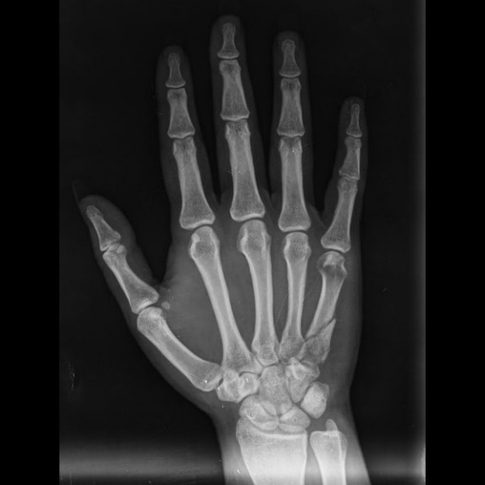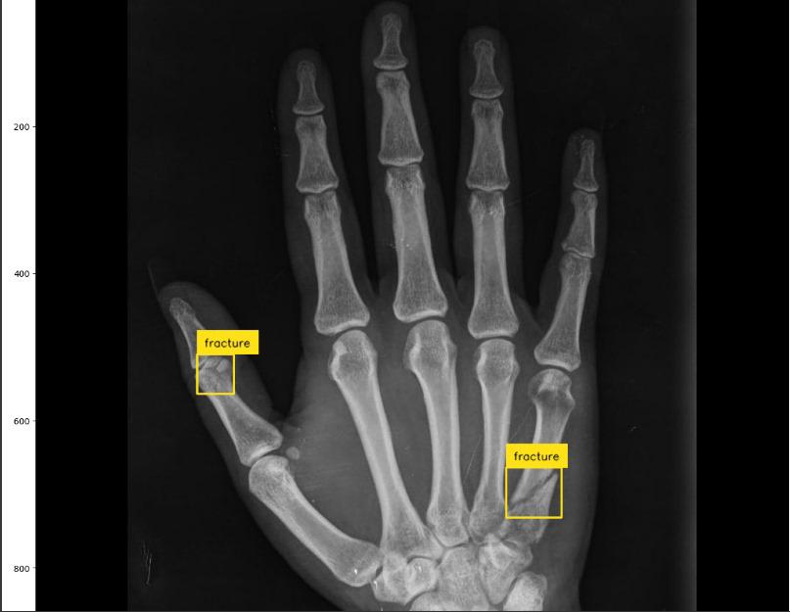

1. DETR (DEtection TRansformer) is a state-of-the-art object detection model introduced by Facebook AI Research (FAIR).

It replaces the traditional anchor-based object detection methods with a transformer-based approach. Transformers are well-known for their success in natural language processing tasks.

2.ResNet-50 is a specific variant of the ResNet (Residual Network) architecture developed by Microsoft. It's a convolutional neural network (CNN) architecture that is widely used for image classification tasks.

In the context of DETR, ResNet-50 is often used as the backbone CNN to extract feature maps from input images.

3. CNN as Backbone: The term "backbone" refers to the initial layers of a neural network that process input data and extract features.

In object detection models, a CNN is commonly used as the backbone to extract hierarchical features from the input image.

4. Transformer Encoder and Decoder, Initially designed for natural language processing, have been successfully applied to computer vision tasks.

The encoder-decoder architecture in DETR involves using transformer blocks in both the encoding (backbone) and decoding stages.

The encoder processes the input image and extracts features, while the decoder refines these features for precise object localization and classification.

5. Training Configuration (100 epochs, 8 batch size):

Training epochs represent the number of times the entire dataset is passed through the model during training.

Batch size refers to the number of training examples utilized in one iteration.

The choice of 100 epochs and a batch size of 8 is a training configuration. Training for more epochs allows the model to learn better representations, and a batch size of 8 means that each update to the model's weights is based on a batch of 8 training examples.

In summary, DETR combines the strengths of transformer-based architectures with a CNN backbone (such as ResNet-50) for object detection tasks. The use of transformer encoder-decoder blocks enables DETR to capture contextual information and relationships between objects in an image. The training configuration (100 epochs, batch size 8) determines how the model is trained over the dataset.

**Model summary:-**

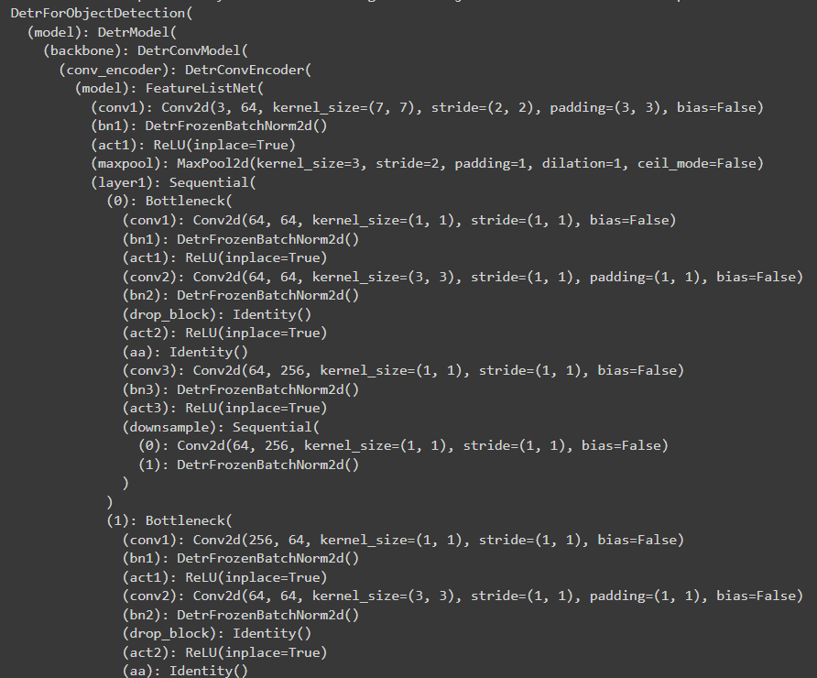

**………………………………………………………………….**

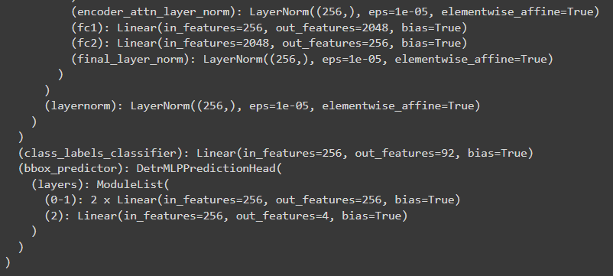

**FORMULAS**

* **Convolution**: -

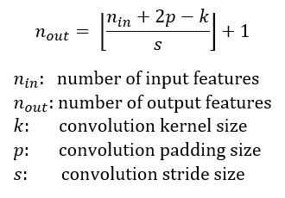

* 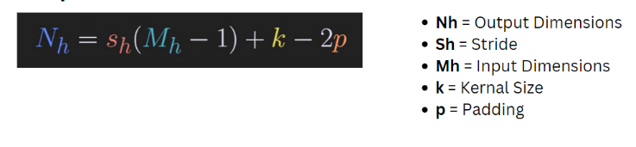**DeConvolution**:-

* **Pooling**:-

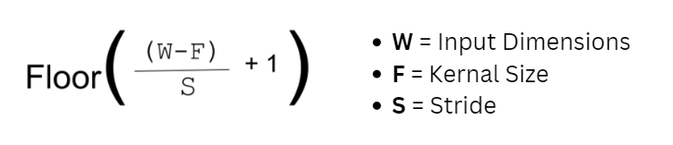

* **Batch Normalization**:-

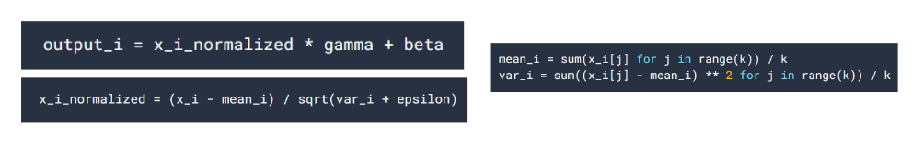

* **SoftMax** :- (By Default Softmax is applied along the last dimension)

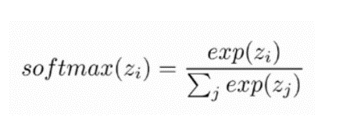

* **ReLu**:-

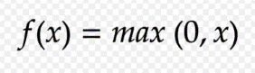

* **GeLu**:-

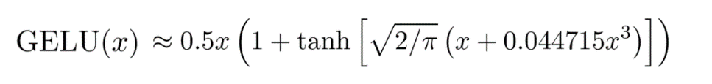

**FRONT END IMPLEMENTATION**

* **Sign Up Page**: If the user is new, he/she can register with Username and Password on this page. These details will be passed to Google Firebase and create a new user and add these credentials to the user database.
* **Login Page**: The user will be asked to login. This functionality will be implemented using Firebase. Username and password from the user will be passed to Firebase. If user doesn’t exist an error is thrown.

 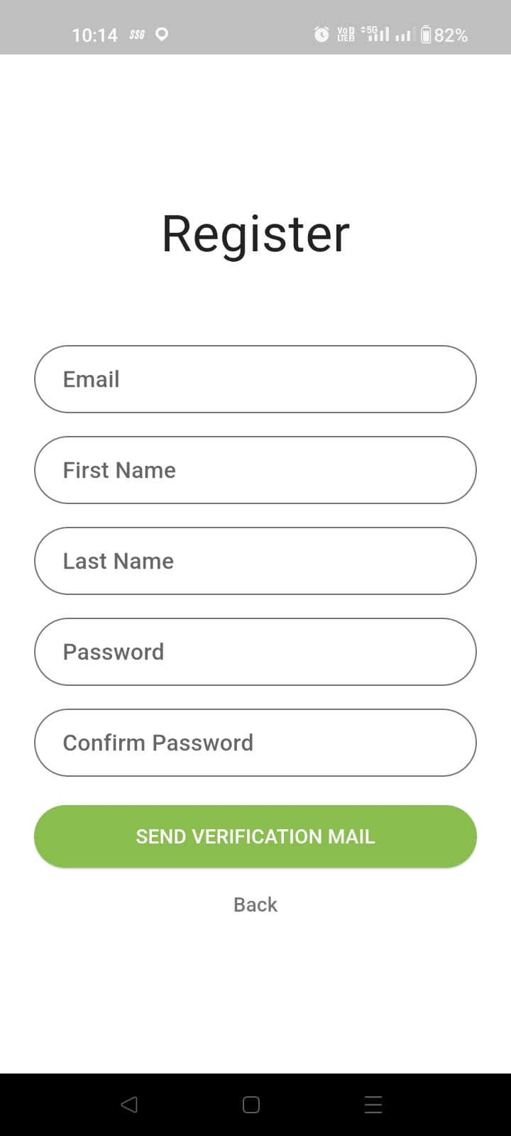

Login Page Register Page

* **Email Verification Page**: The user is directed to the email verification page after logging in. User has to enter the email id and click on verify OTP button. The user receives a verification mail.

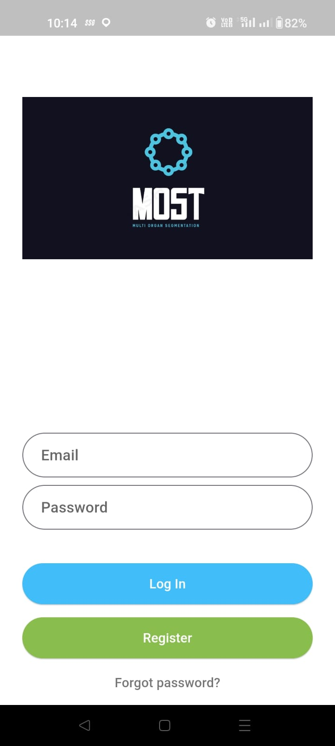 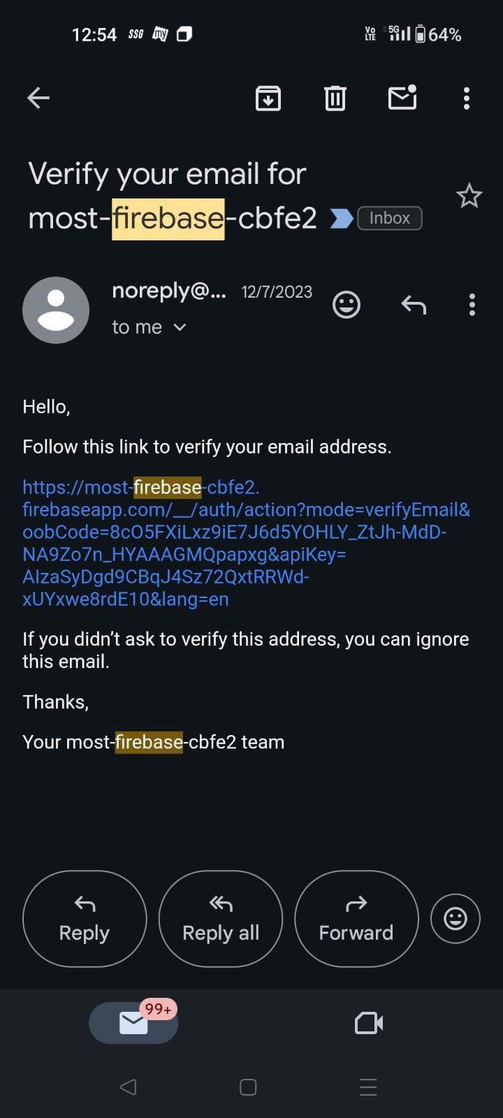

Email Verification Page Verification Link to Email

**Phone Verification Page**: Users can conveniently log in using their phone number, with a secure phone verification process, in addition to the traditional email login method.

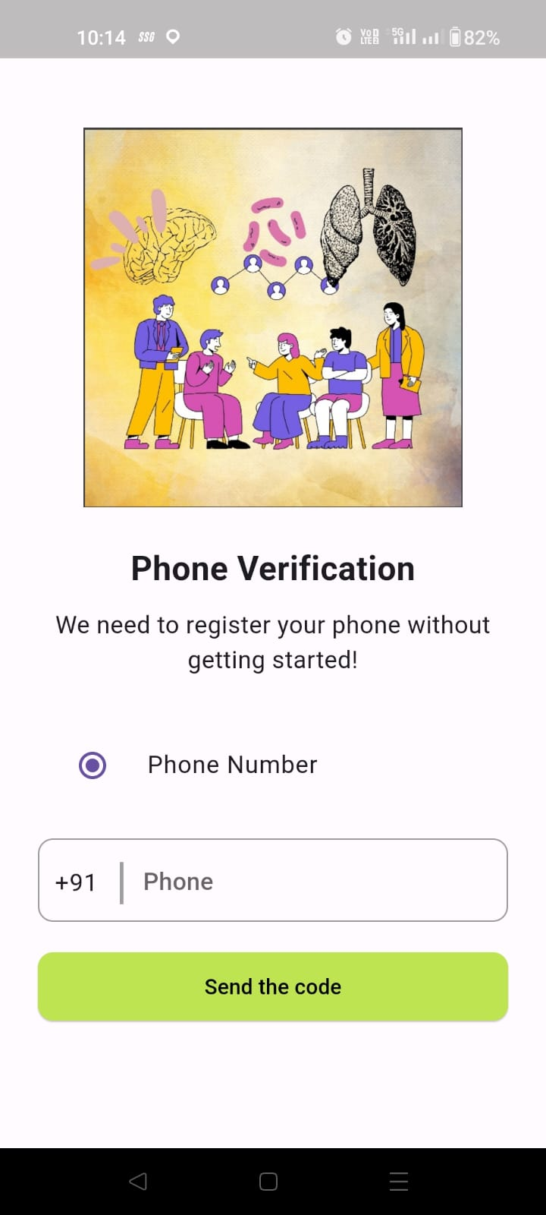. 

Phone Verification Page-1 Phone Verification Page-2

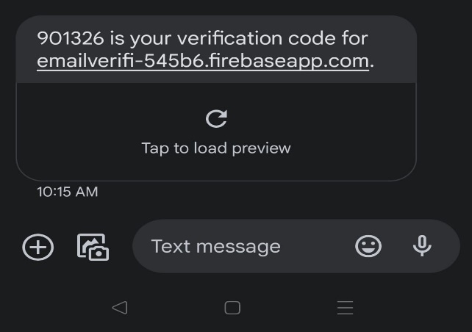

OTP to Mobile Number

* **Verified Phone Page**: This is the page where we can see that our phone number has been verified and clicking on next will navigate the page to the Options Model page.



**Options Model Page**: The Options Model Page serves as the gateway for users to choose from three distinct models, each tailored for specific image processing tasks. Users are presented with intuitive buttons representing the models UNET, UNETR(main project), DETR.

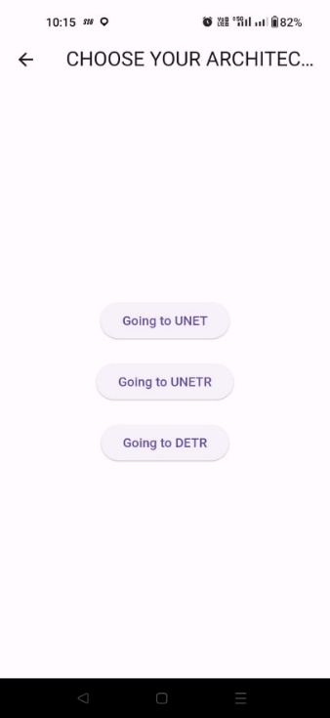

Options Page

**Uploading and Segmentation of image**

* When we click Select image, we need to pick an image from image directory or gallery. There are three options specified Ground truth, Select image and Segment image.
* Here if we don’t have the mask image or ground truth we can directly click on the segment image after the selecting the image, a concatenated image, displaying the original image, and predicted image consecutively in a vertical sequence.

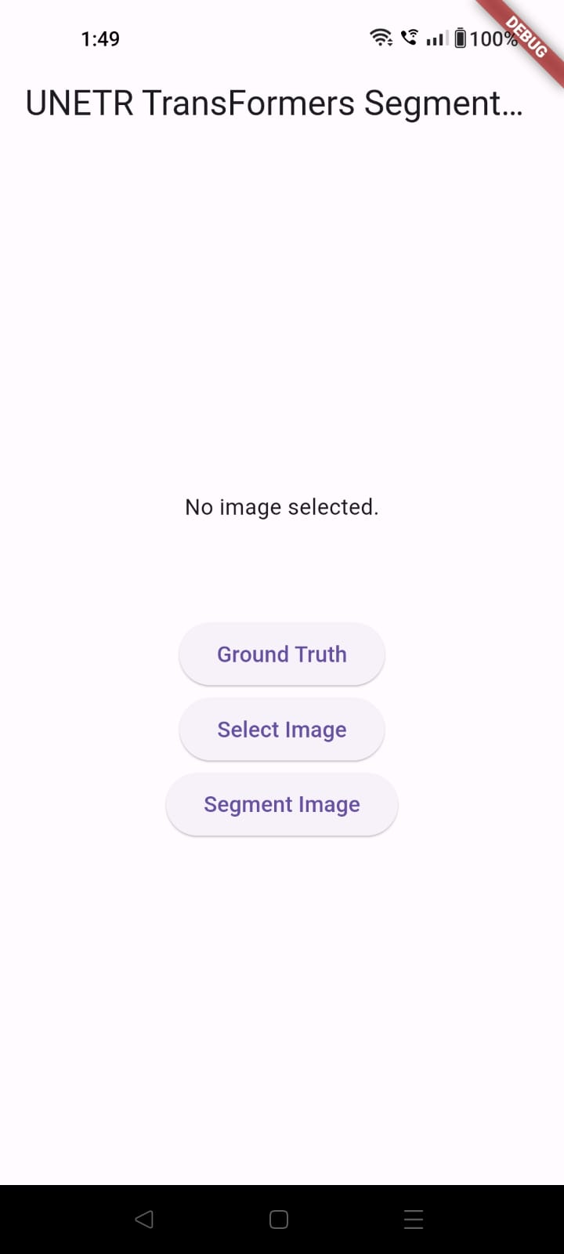 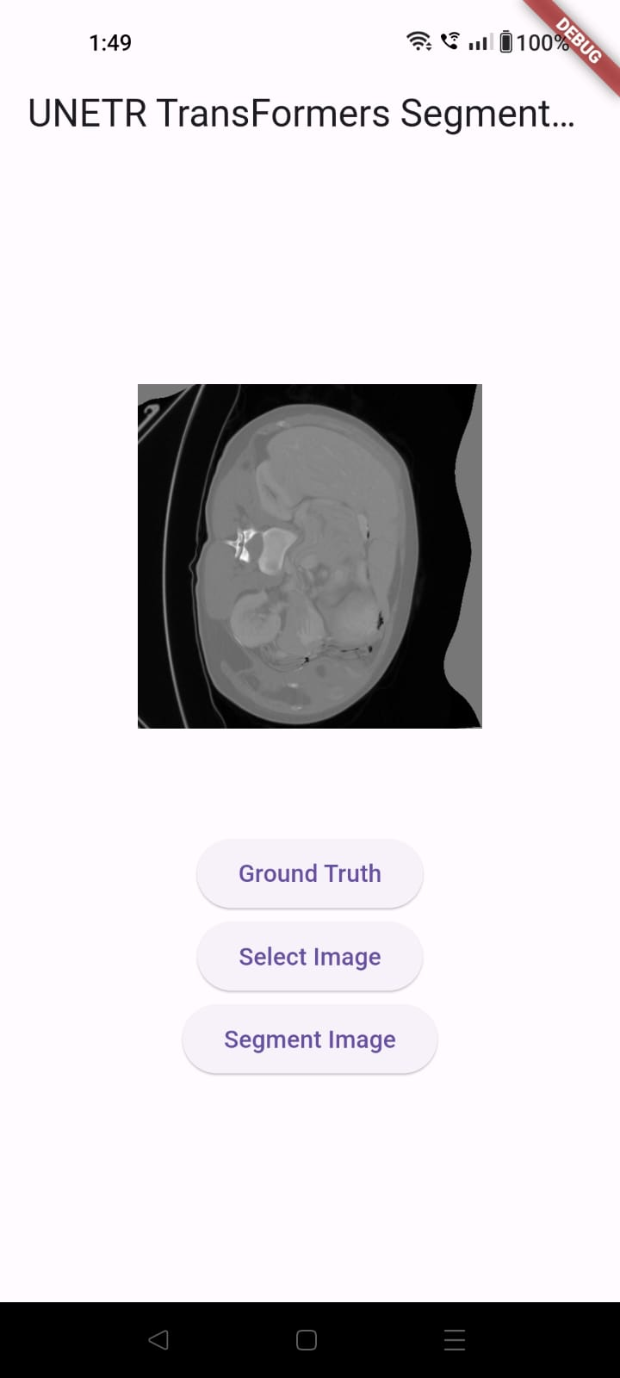

Uploading Image Interface Uploaded Image

* When we click on segment image button which will show new layout that includes a concatenated image, displaying the original image and predicted image(Segmented image) consecutively in a vertical sequence.

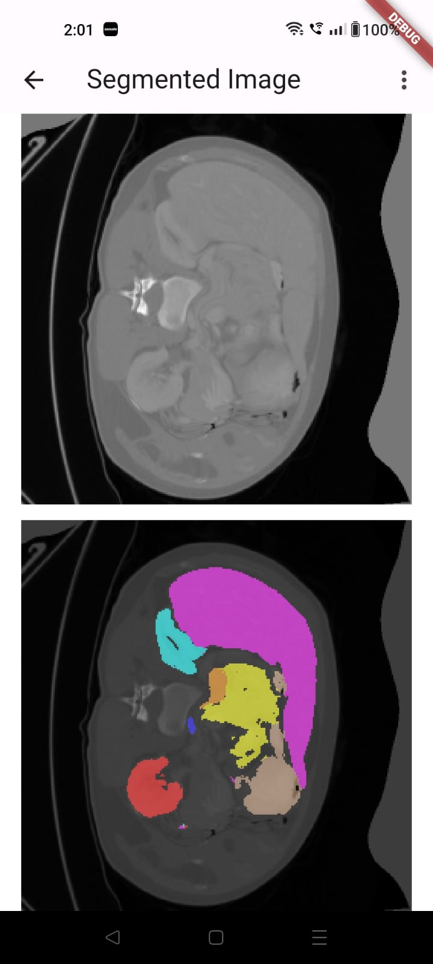 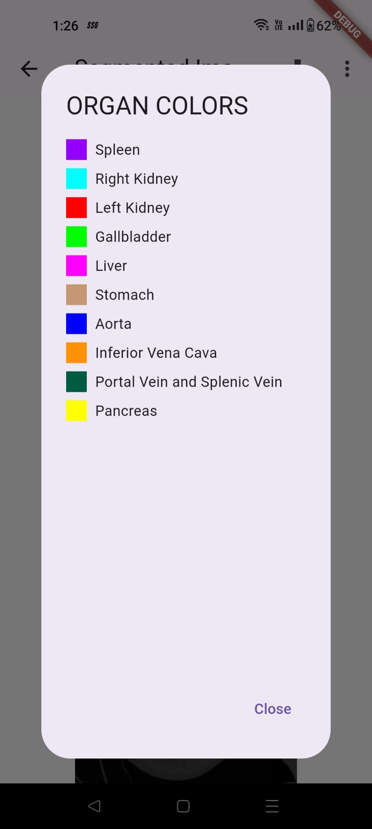

By clicking on three dot button on the top right corner we get to see the organ colours of various organs of the segmented image.

* If we want the ground truth in the middle of the combined image as shown before, the user should know the image file name according to the dataset of the project, to type the image file name, the user should click on the Ground Truth button (example:“img0043”) and then clicking on segment image button, which will show new layout that includes a concatenated image, displaying the original image, segmentation mask(ground truth), and predicted image (Segmented image) consecutively in a vertical sequence.

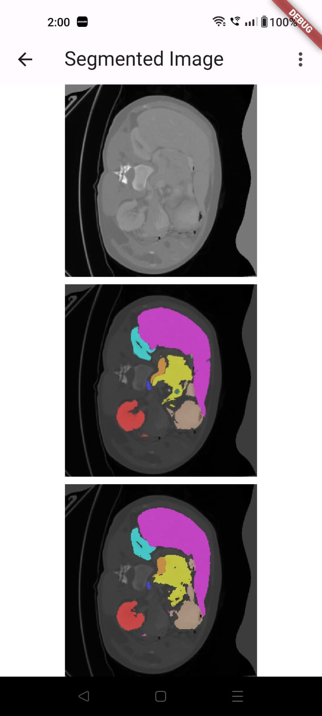 

By clicking on three dot button on the top right corner we get to see the organ colours of various organs of the segmented image.

* The Same process for UNET model and DETR model.

**UNET MODEL**:

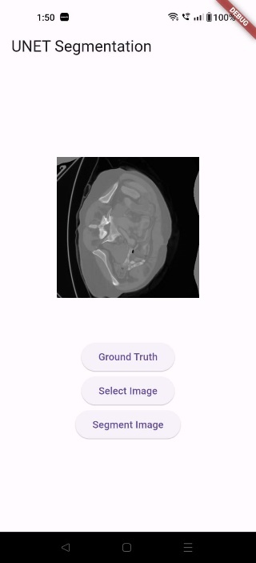 **or 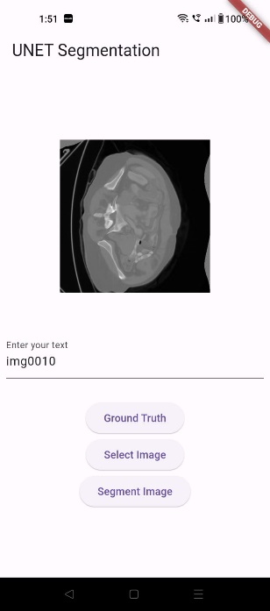 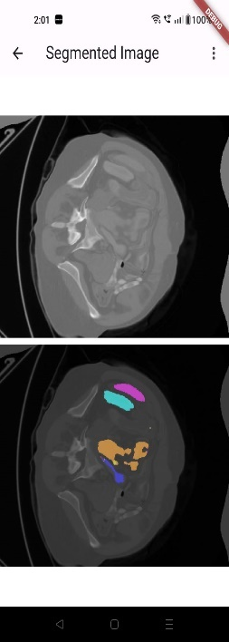 or** 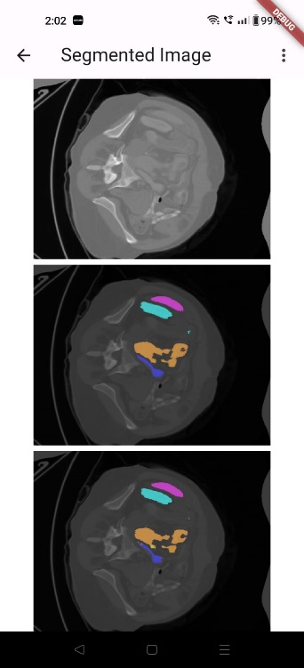

**DETR MODEL** Detections:

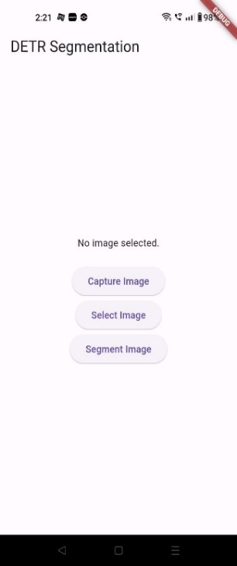 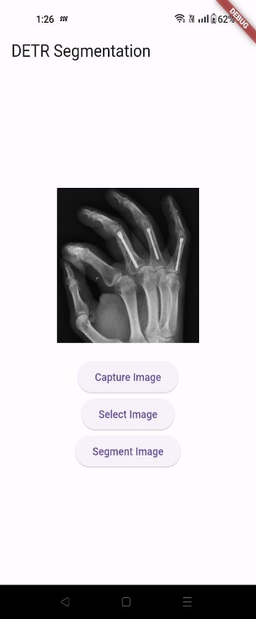 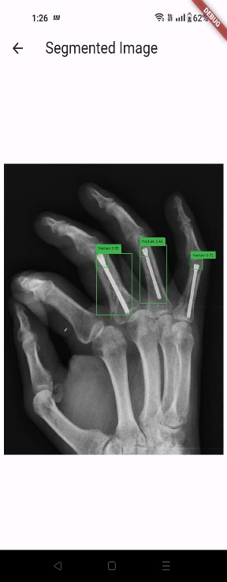

**Flask to Flutter and Structure of Flask:**

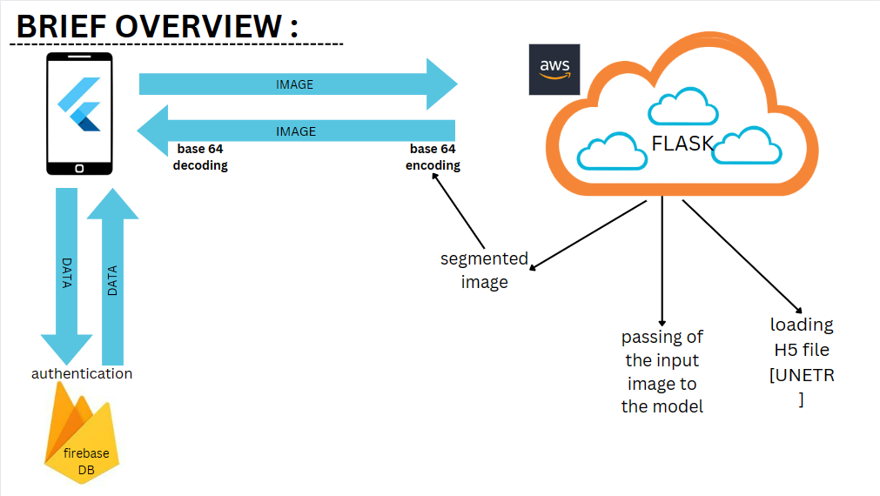

* **Flutter** mobile application initiates the process by allowing users to capture or select an image through its user interface (UI).
* The selected image file is then transmitted to a Flask server using a **Multipart request**, leveraging the server's API.
* Upon receipt, the **Flask** server performs base64 encoding on the image data. Subsequently, the encoded data undergoes model inference to generate segmented image data.
* The resulting segmented image data, also encoded in **base64 format**, is sent back to the Flutter app via the **Flask server's API.**
* The Flutter app then decodes the received segmented image data and displays the **segmented** image on its UI.
* This process seamlessly integrates image handling, server communication, model inference, and **UI interaction**, facilitating a cohesive image segmentation application.

This the **Flask Application** process of segmentation of image and displaying the image in the Flutter app UI.

**Structure of Flask:**

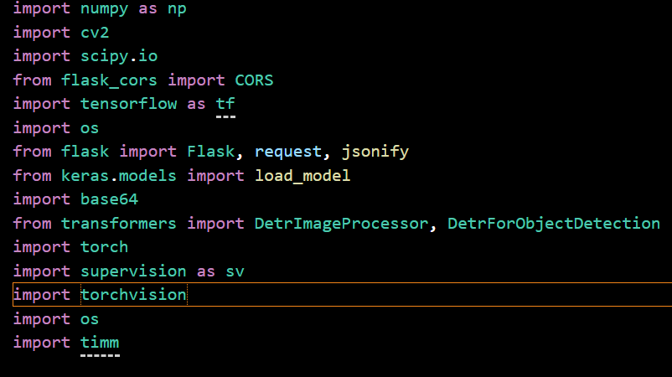

The **modules** getting imported in the Flask application for segmentation and processing.

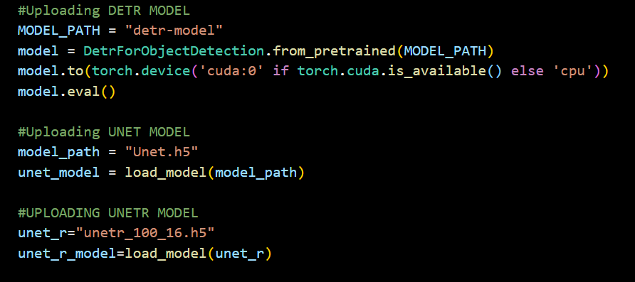

* In this **workflow**, we will be loading three models utilizing the load_model method from the Keras library. Each model will be loaded by specifying its respective file path, and the models are stored in the widely used **Hierarchical Data Format 5** (H5) file format.
* By employing the **load_model** function, we seamlessly bring these pre-trained models into the Python environment, setting the stage for further utilization in tasks such as **image segmentation** or other deep learning applications. The H5 files serve as repositories for the model architectures, weights, and other essential configuration parameters, allowing for efficient and straightforward integration into our project.

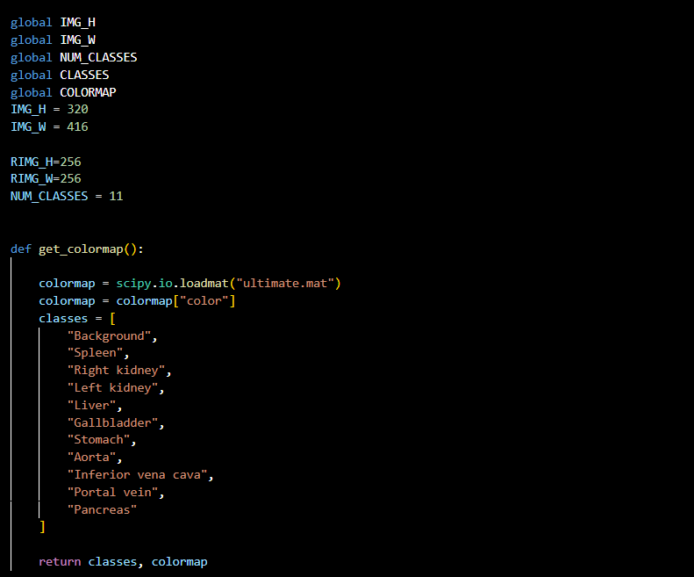

* In this process, we initiate the creation of a color map by extracting organ colors from a **MATLAB file (.mat).** The color map is crucial for mapping and distinguishing various organs within the images. The function responsible for this task returns both the classes and the colormap.

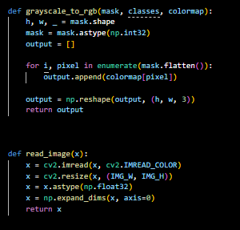

* We read an image using the **read_image()** function, which takes the image path as a parameter. Subsequently, we convert the grayscale image to RGB using the **grayscale_to_rgb()** function. This conversion involves taking the mask image along with the classes and colormap as parameters. By seamlessly integrating these functions, we ensure a streamlined workflow for **reading and processing images**, allowing for efficient color mapping and RGB conversion in the broader context of our image processing pipeline.

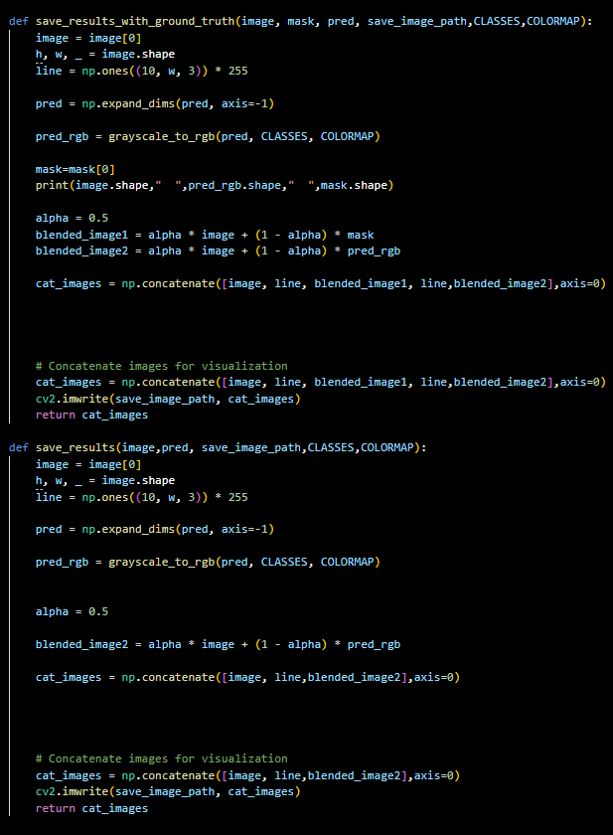

* In this stage of the process, we implement the functionality to save and return a **concatenated** image. The resulting image can either display the original image alongside the segmented image or feature the original image, **mask**, and segmented image arranged in a **vertical sequence**.
* In the data interchange process between the Flask server and the Flutter application, **Base64 encoding** serves as the key mechanism for both encoding and decoding images. When transmitting data from Flask to Flutter, the server encodes the image data into a Base64 format, ensuring a platform-independent representation that can be easily transmitted over the network. Upon receiving this encoded data, the Flutter application employs **Base64 decoding** to revert it back to its original image format, allowing for seamless integration and display within the app's user interface.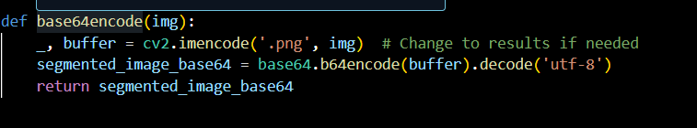

**Integration of Flask with Flutter**

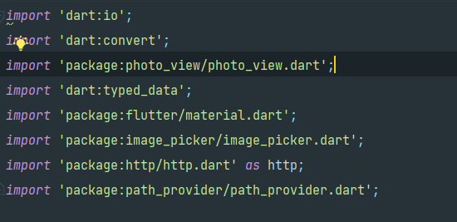

* In the **communication** flow between the Flutter front-end and the Flask back-end, a multipart request is employed to transmit both an image file and an accompanying input text, serving as a request to specify the desired image file name. This request is sent to the Flask server using the POST method, directed to the specified **AWS public IP address** to the server endpoint /segment_unetr. Upon receipt of the streamed response, the system checks the response status code, and if it equals 200 (indicating success), the response is further processed. The received response is decoded using **jsonDecode** to extract the **UTF-8 string** contained within. This string, typically representing an image in Base64 format, is then subjected to Base64 decoding. The final step involves displaying the resulting image within the **Flutter app's user interface**, providing users with a visual representation of the processed image as conveyed by the Flask server.

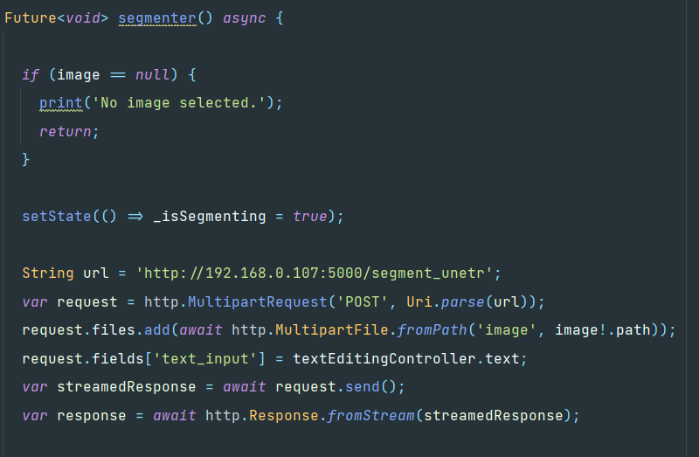 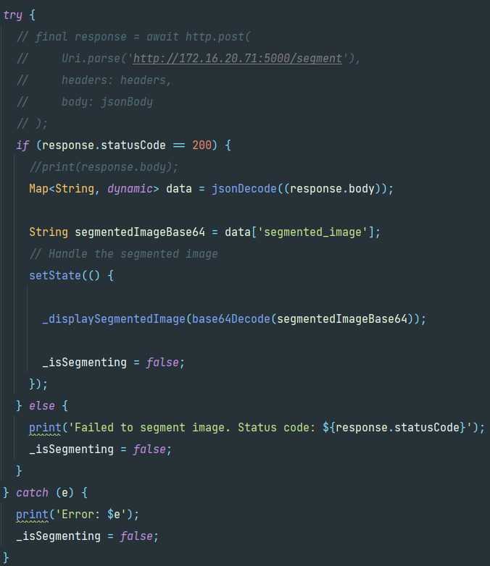

* The server endpoint of the flask shown below will send the **JSON response** to the flutter application by using various functions.

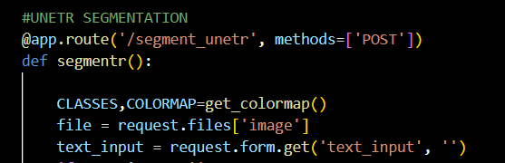 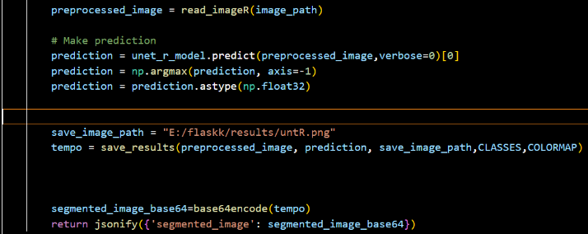

**A brief Flow of the Communication between Flask and Flutter.**

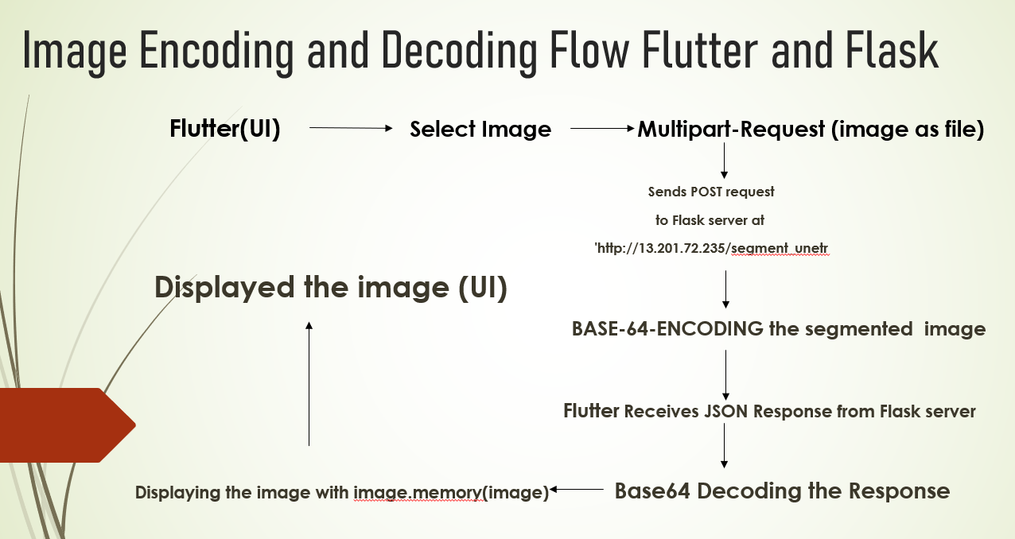

**DEPLOYMENT OF MODEL USING AWS:**

**Step 1:** Setting up of EC2 instance in AWS Management Console.

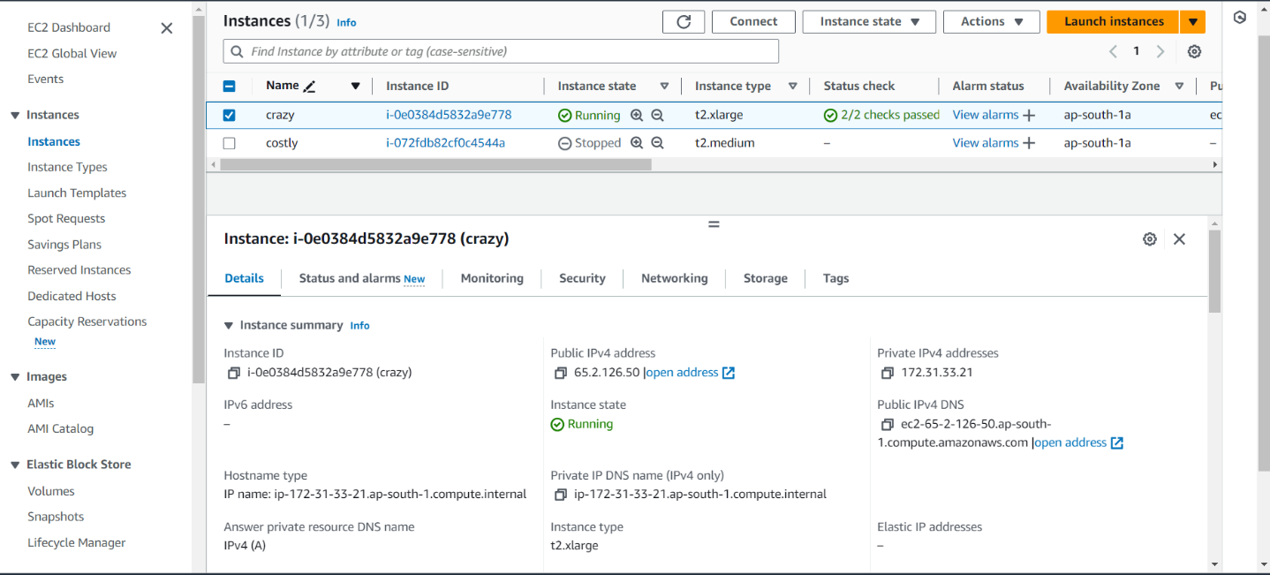

The instance named “crazy” which is type of t2.xlarge, with a public IP address 65.2.126.50.

**Step 2:** After the deploying the Flask in the AWS , run the command “python org_flask.py” (python flask file name) in the command prompt and press enter.

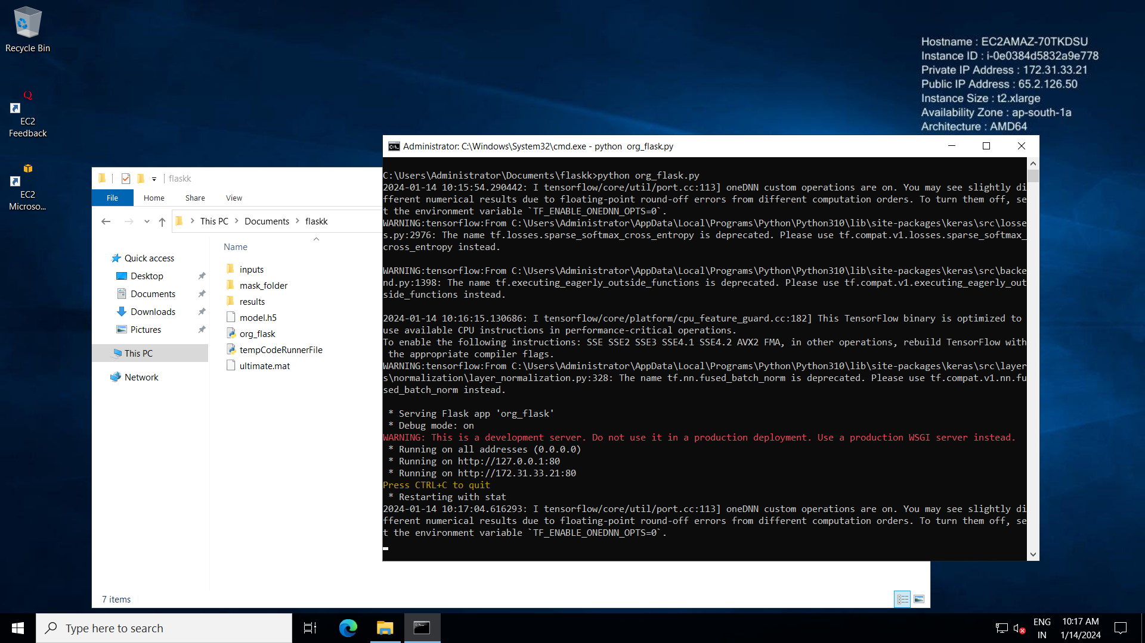

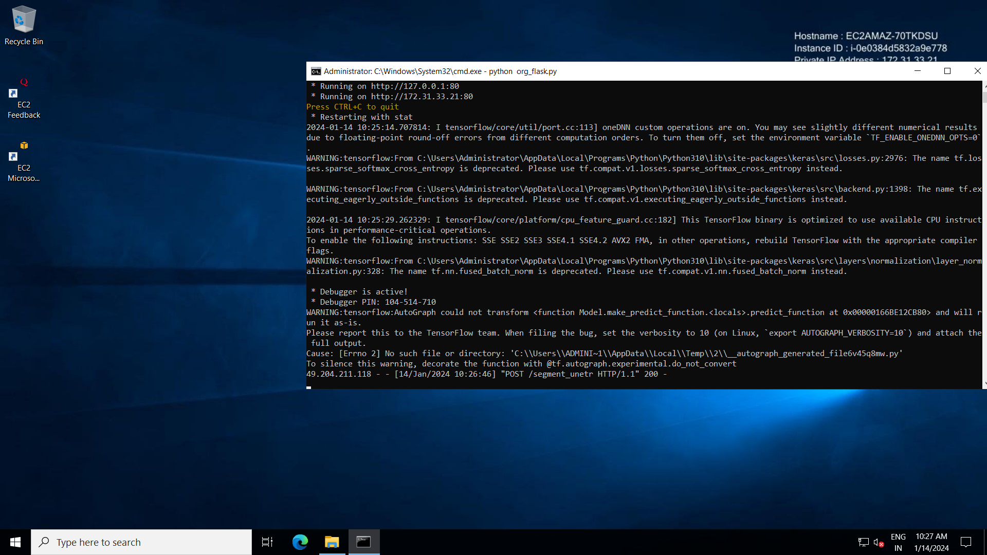

The request received can be seen on the command prompt with status code 200.

**Training the model:**

The model was trained on the synapse multi organ dataset which consist of 4720 images, which were split as 60% for training, 20% for testing and 20% for validation. The training was done on 3 types of processing units

1. CPU
2. GPU
3. TPU

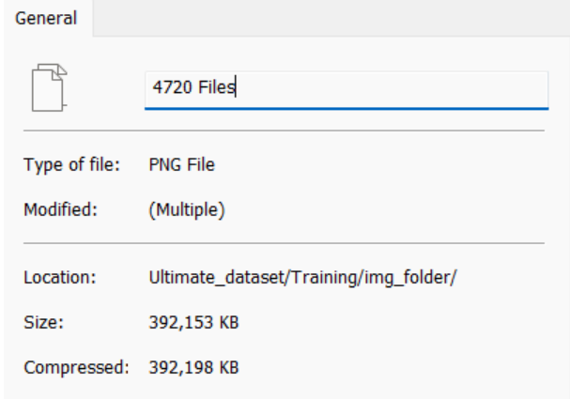

**1. Model training with CPU: -**

The model was first trained on Local CPU with 4 core processor and 16gb RAM, the CPU training was the lowest efficient.

As it was taking more than 6 hours for each epoch to run on a batch size of 2, the CPU was not capable to allocate memory and process the data when batch size was increased from 2 and was throwing the OOM (out of memory) error.

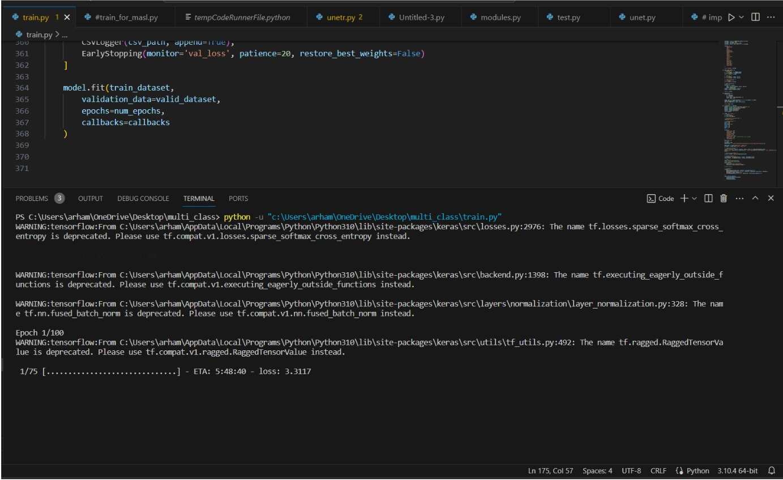

**2.Model training with GPU: -**

The model was trained on GPU on 2 different online cloud platforms

a) Google Colab

b) Kaggle

**a) training the model on google colab:-**

The model was trained on google Colab’s T4 GPU which consist of 16 gb of GPU memory , here the model was trained on batch size of 4, 6 with 50 and 100 epochs each. The T4 GPU was a good approach when compared with CPU, but it was slow and wasn’t able to run with batch size more than 6

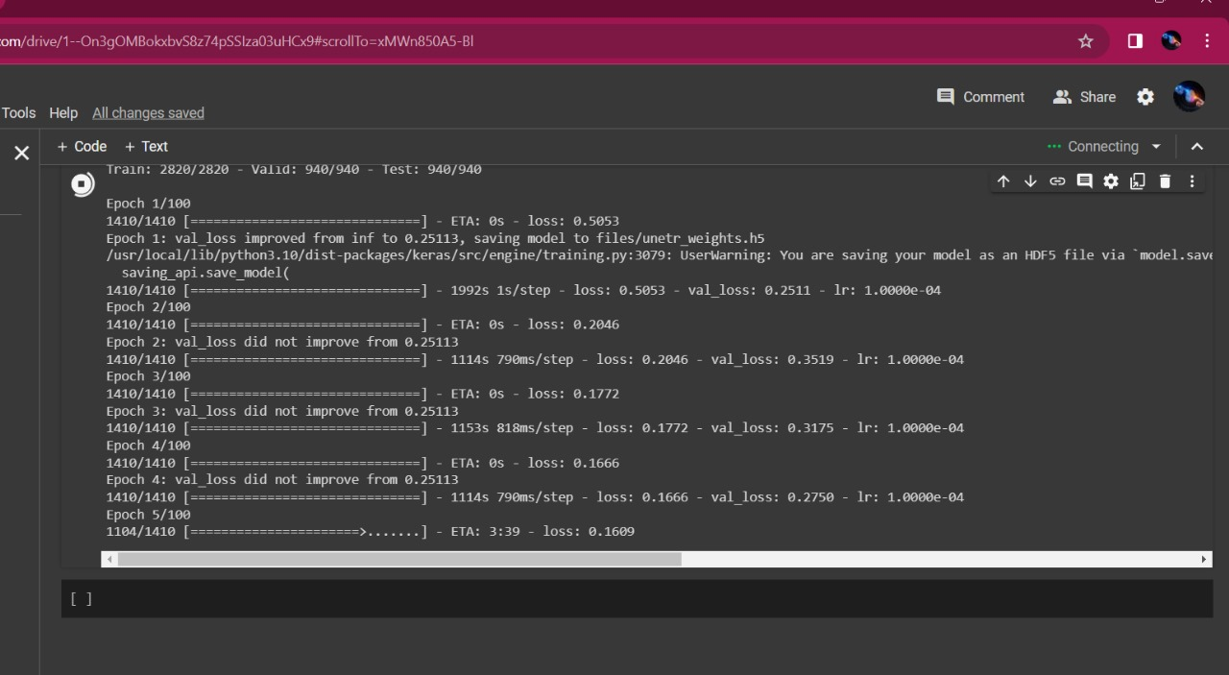

**b) training the model on kaggle :-**

The kaggle data science platform provided with 2 units of T4 GPU which is double of that provided by google colab, here 32 gb of GPU memory was utilized to train the model on batch size 8 with 50 and 60 epochs. The ETA for each epoch was around 200 seconds ( estimated time of arrival )

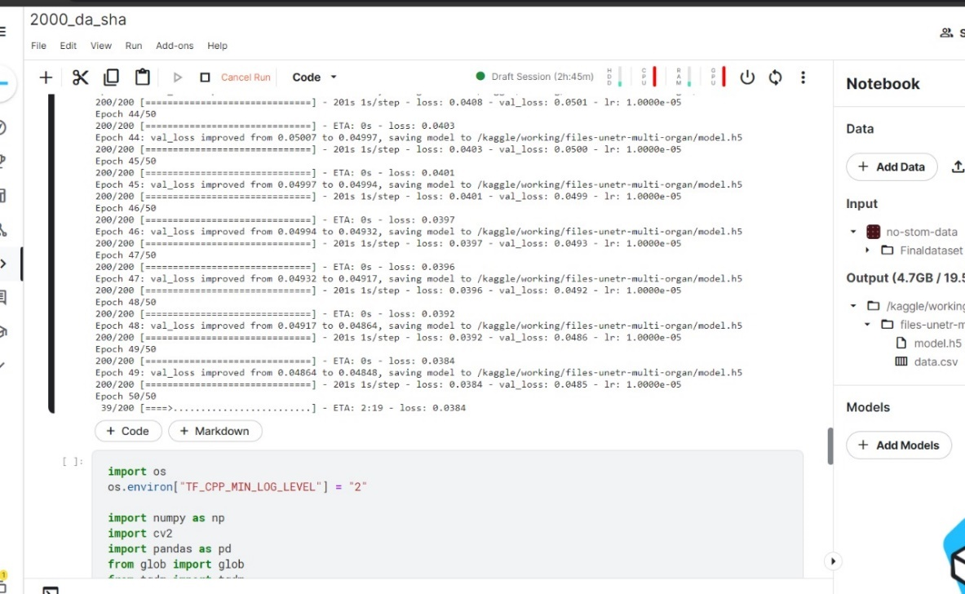

**3. Model training with TPU (VM v3-8): -**

The model was trained on TPU (tensor processing unit). The TPU can be considered as the best processing unit to train the model with high amount of data. We were able to train the model with batch size 16, 32 with the help of TPU. TPU’s are equipped with 128GB of high-speed memory allowing larger batches, larger models and also larger training inputs.

The ETA for each epoch was around 60 seconds.

There is an edit in the code while running it on the TPU: -

*TPU detection and initialization for Kaggle*

*try:*

*tpu = tf.distribute.cluster_resolver.TPUClusterResolver()*

*tf.config.experimental_connect_to_cluster(tpu)*

*tf.tpu.experimental.initialize_tpu_system(tpu)*

*strategy = tf.distribute.TPUStrategy(tpu)*

*except ValueError:*

*strategy = tf.distribute.MirroredStrategy()*

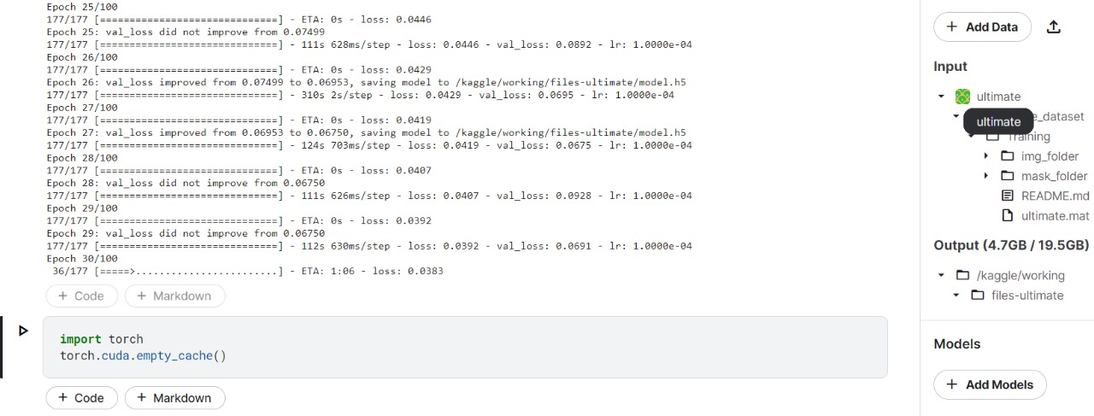

In conclusion;

Total time taken to train the model

CPU - 6 hours per epoch

GPU - 200 seconds, 5.5 hours to train

TPU - 100 seconds, 2.7 hrs to train

**Platforms used:**

AWS Sage maker, But we couldn’t train on it due to “Resource Exhausting error”. So trained on Kaggle.

* Visual Studio Code for Front-end and back-end development.
* Kaggle for Dataset
* Jupyter Lab/ Notebook for model building

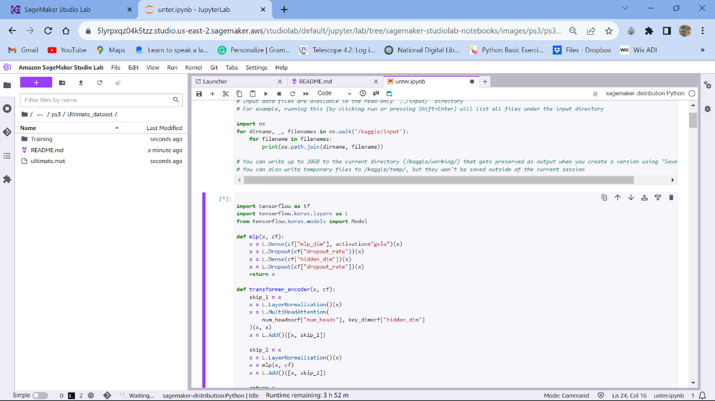

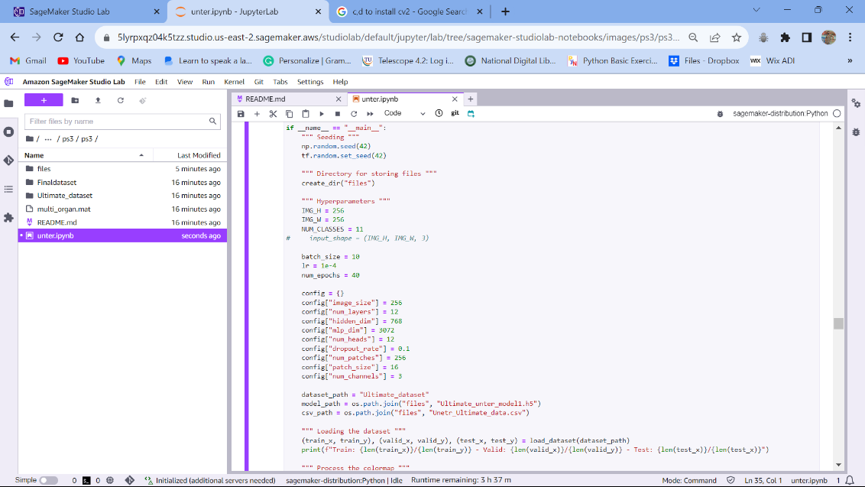

Started training:

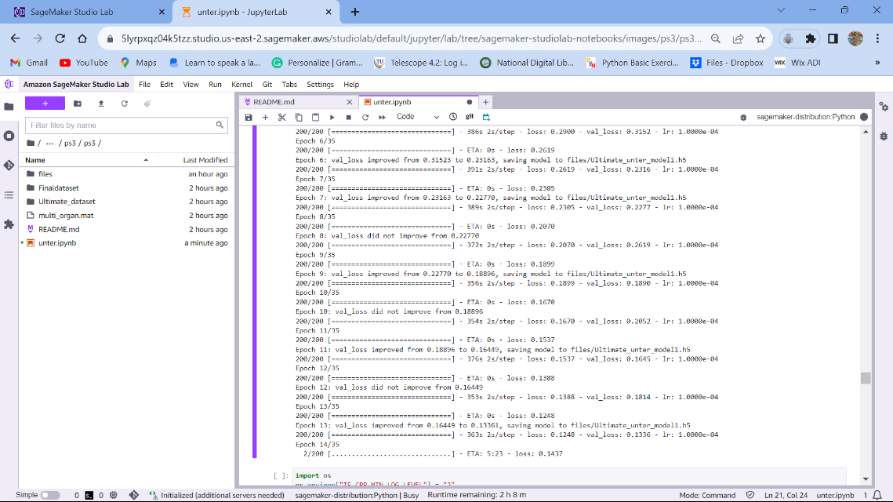

Ended up with error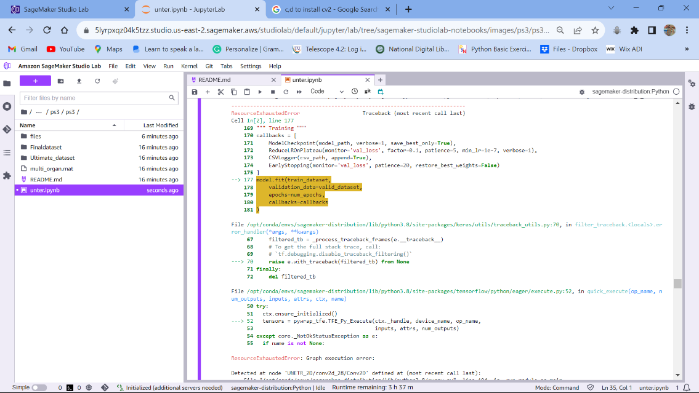

**Projects Screenshots**

**Unetr model:-**

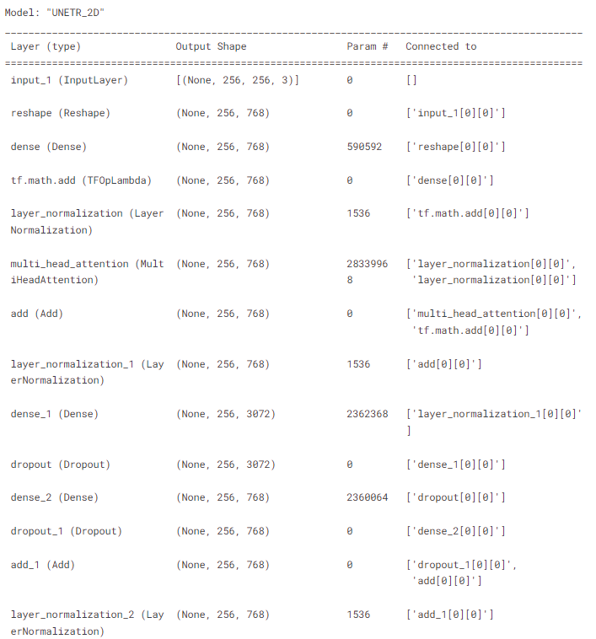

………………………………………………………………………………………………………………….

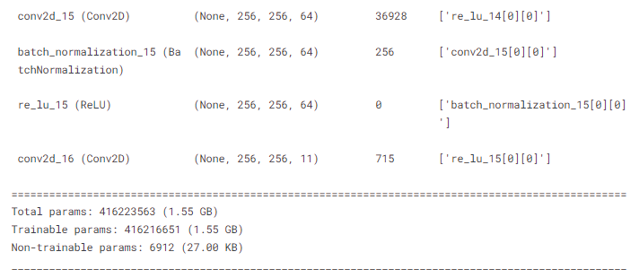

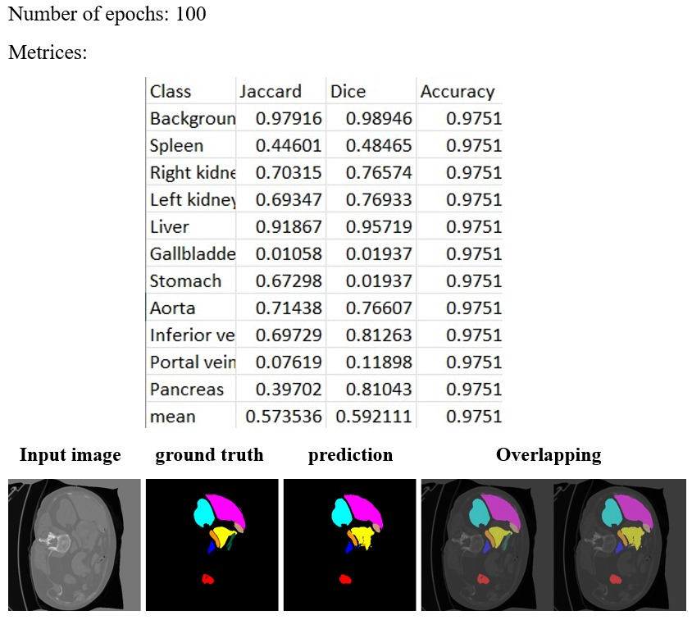

**Unet model:-** 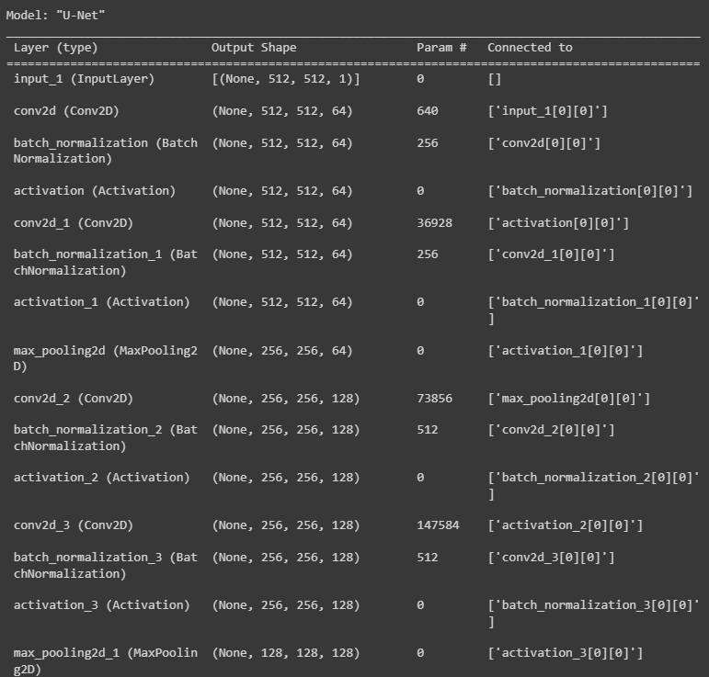

…………………………………………………………………………………………………………………………………………………………….

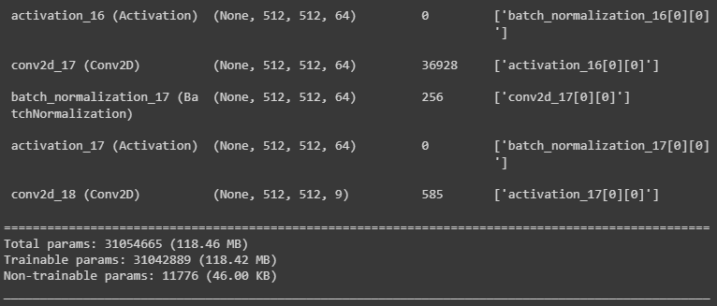

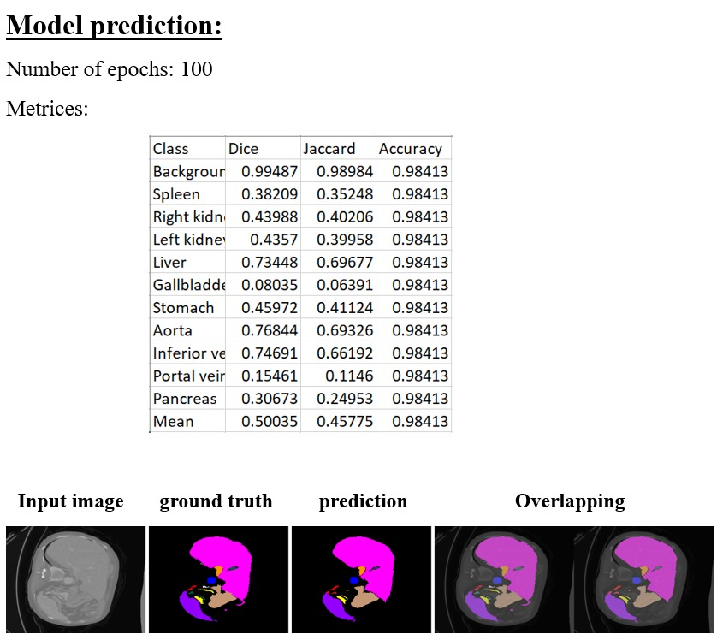

**Detr model:-**

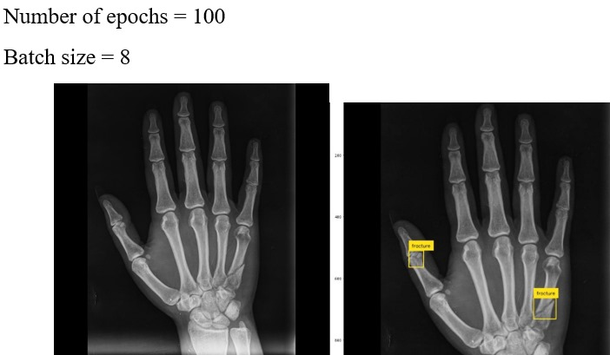

**Mobile application: -**

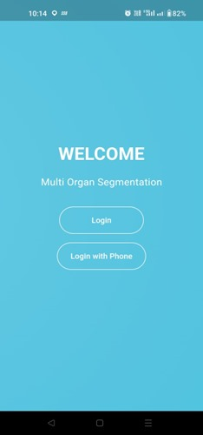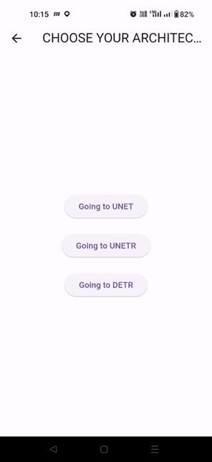

Unetr: -

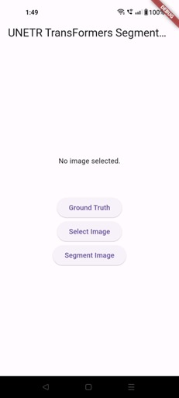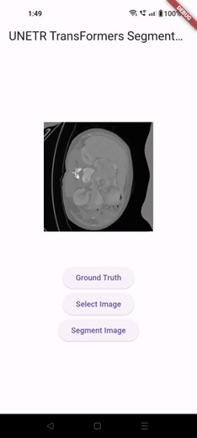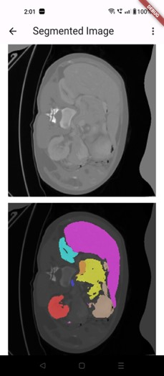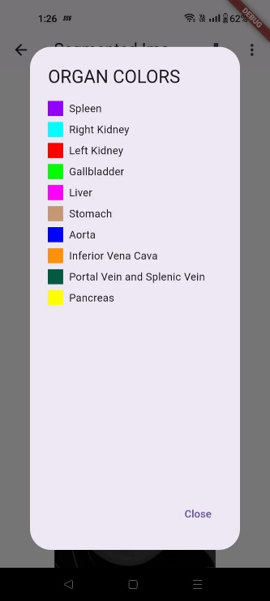

Unet:-

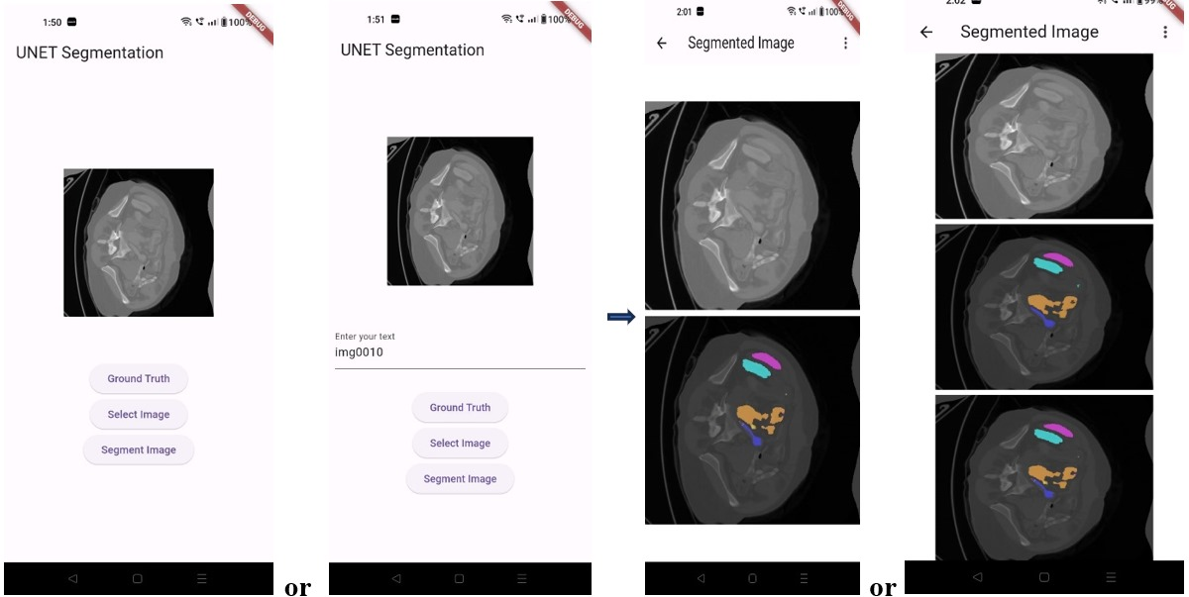

Detr: -

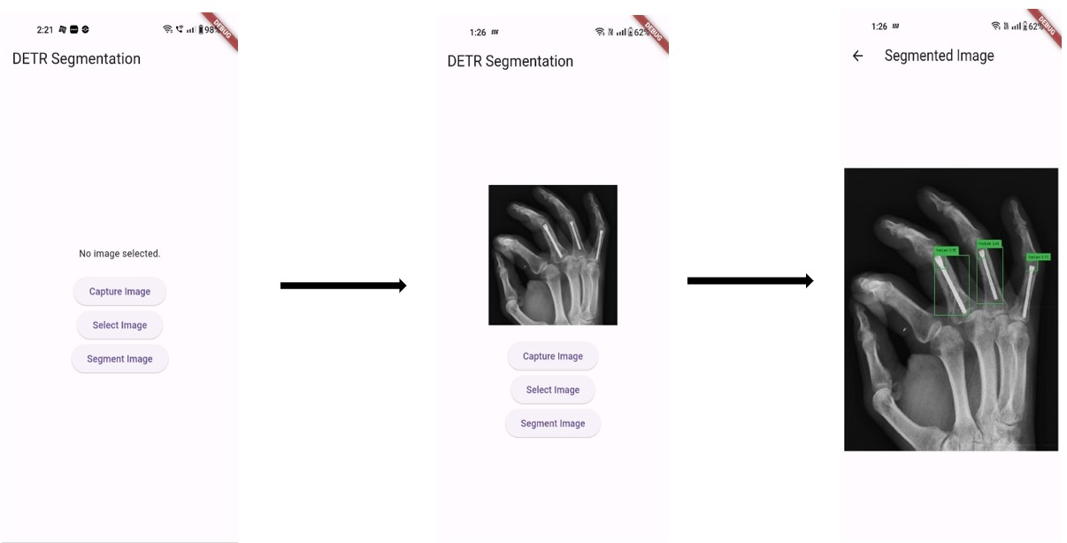

EC2 Instance:-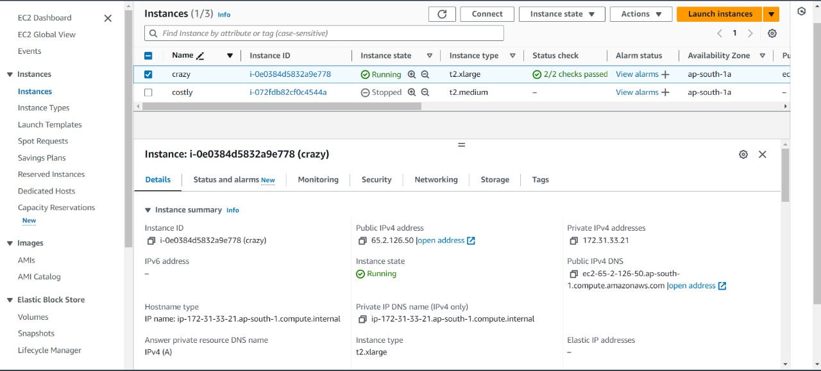

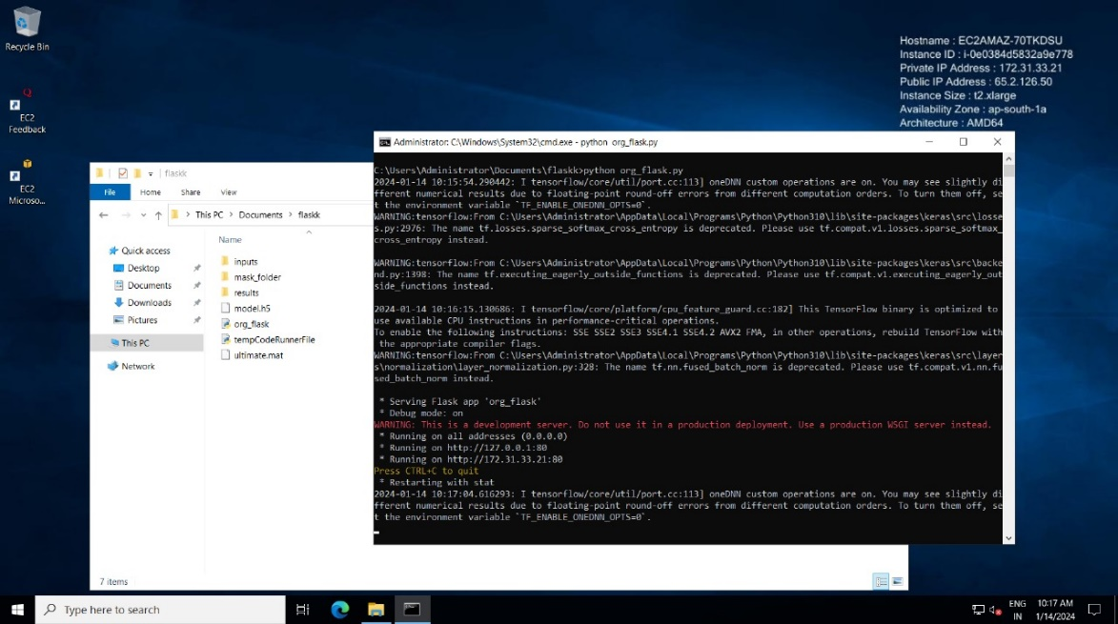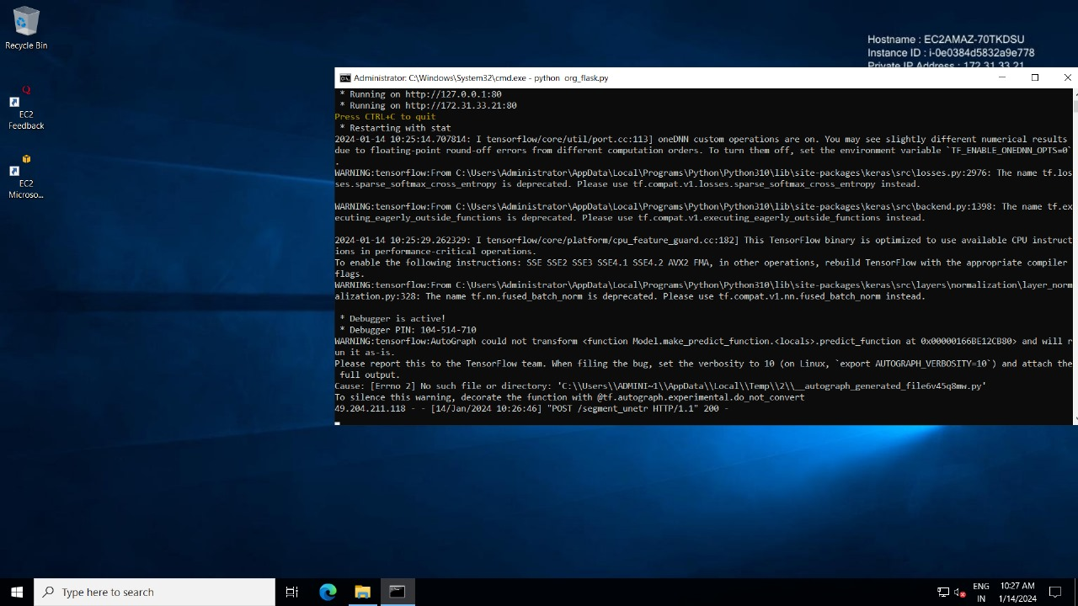

Training With GPU:-

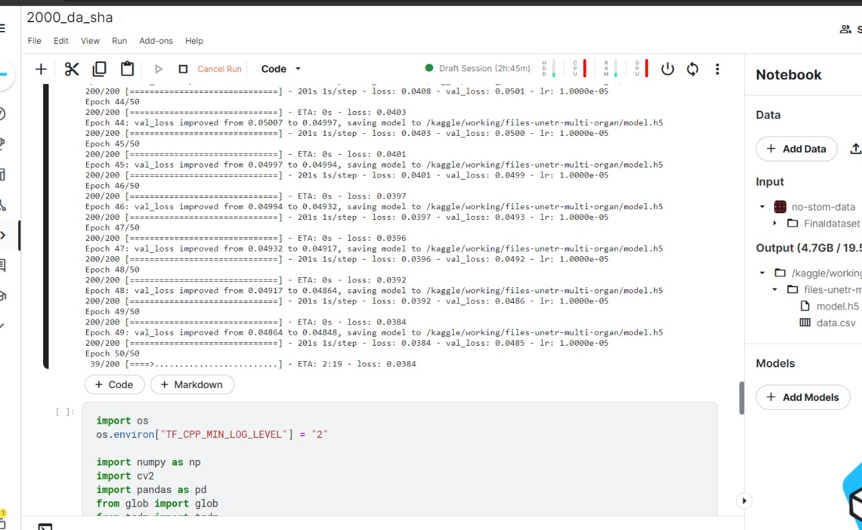

Training With TPU:-

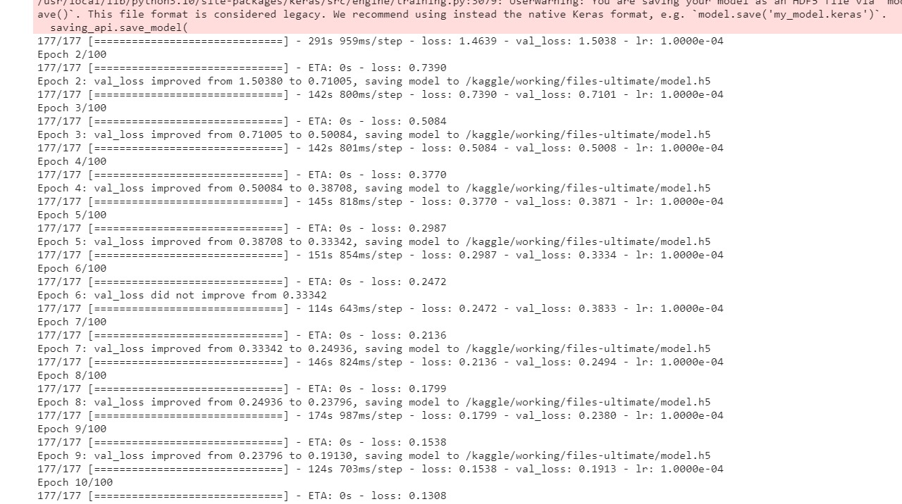

Training With CPU:-



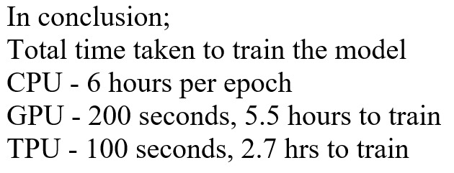

**Summary**

* An End-to-End Android Application for segmenting CT scan images is designed and deployed, that can be used for segmenting 10 organs from a abdomen CT scan Image of a Human body.

**REFERENCES**

* UNETR: Transformers for 3D Medical Image Segmentation.

<https://openaccess.thecvf.com/content/WACV2022/papers/Hatamizadeh_UNETR_Transformers_for_3D_Medical_Image_Segmentation_WACV_2022_paper.pdf>

* The Architecture Code for the UNETR Model was taken from *YouTube* Resource: **IDIOT DEVELOPER**.

<https://youtu.be/rebyh-HjS3E?si=g3YgcBH7GZgZL0lb>

* Understanding Multi Class Segmentation Plus UNET Architecture from *YouTube* Resource: **IDIOT DEVELOPER**.

<https://youtu.be/ng_gAxQnXAY?si=bNH-oM4Wcjs-eweg>

* Referred ***Transnet*** to Know the Importance of Transformers part while Image Segmentation from paper <https://arxiv.org/pdf/2102.04306v1.pdf>
* Detection Transformer (DETR) Architecture was taken from *YouTube*  
  Resource: **Code with Aarohi.**

<https://youtu.be/xuh37qziXnw?si=YtvSESkRzxuPhG6j>

* Understanding of Library codes of Kera’s from GitHub.

<https://github.com/keras-team/keras/tree/master/keras>

* Flutter-Firebase Documentation: <https://firebase.google.com/docs/auth/flutter/start>
* Flutter App Email Authentication:

<https://firebase.google.com/docs/auth/flutter/email-link-auth>

* Flutter App Phone OTP Authentication: <https://youtu.be/ftFNV6k0xBY>
* Flutter Dependencies: <https://pub.dev/>
* Flask Deployment on AWS: <https://youtu.be/uhO2JvOvTWU>
* Chat GPT- Debugging Tool: <https://chat.openai.com/>